Homework – Friday 2nd September
English
Year 1
Next week we are going to be writing some instructions on a potion from a Traditional Tale. English homework is going to be practising write some simple instructions.
Look at the photos below on brushing your teeth:

Can you write some instructions on how to brush your teeth? Think about the order.
Use numbers to separate your instructions.

Year 2
Please complete the same activity above, but use the sentence starters below to help you order your instructions.
Below are some sentence starters to help you:
- First,
- Next,
- Then,
- After,
- Finally

Maths:
Year 1:
Can order these objects?
Draw lines to order the objects from greatest to smallest. 1 is the greatest number and 3 is the smallest.
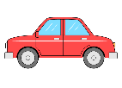
1

2

3

Can you order these numbers?
10 7 12 3 5 9

Challenge
Can you jump 2 spaces forwards from 7?

Can you jump 4 spaces back from 6?

Year 2:
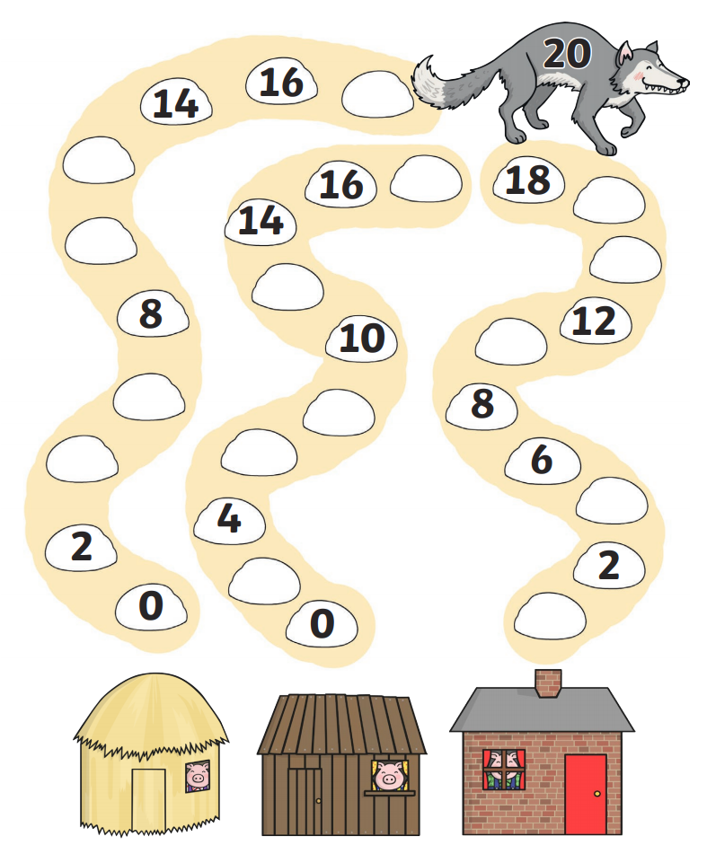
Can you count in 2s? Fill in the missing numbers when you count in 2s.

Can you count in 5s? Fill in the missing numbers when you count in 5s.
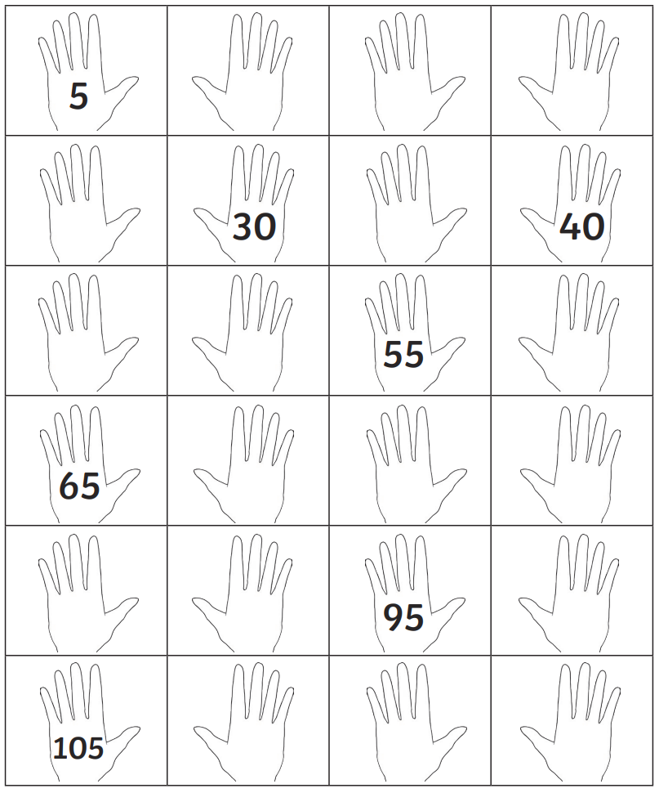

Challenge:
Can you take 7 jumps forwards from 6?

Can you take 5 jumps back from 19?

