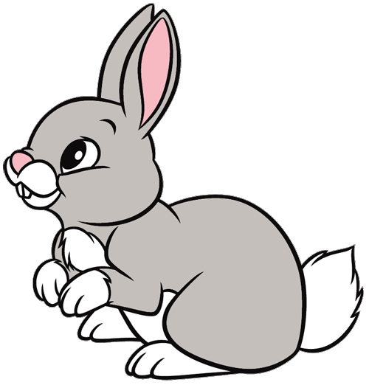

Rabbits Class Home Learning

11th November

Read Write Inc

Can you practice forming the letters below…?

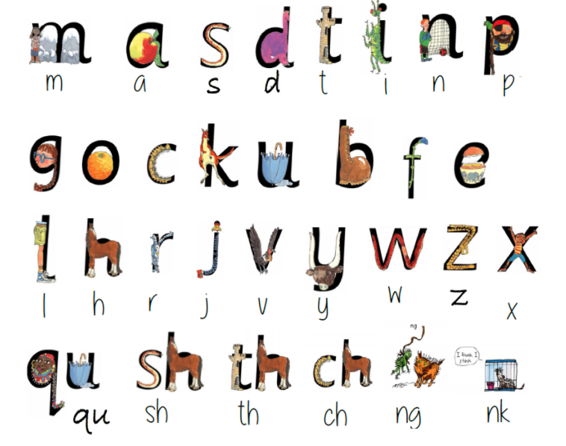

Can you answer these questions?

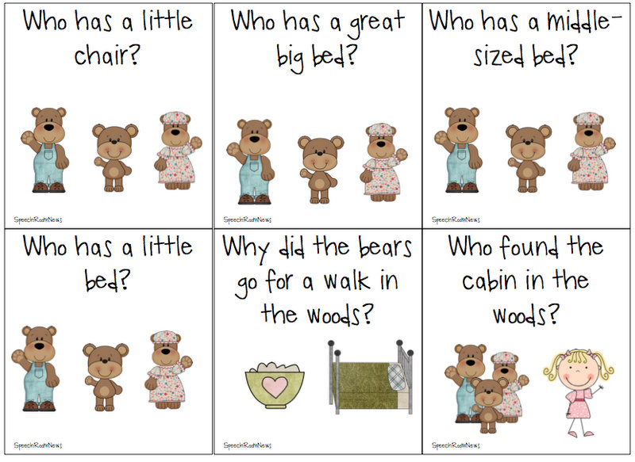

This week we have enjoyed reading ‘Goldilocks and the Three Bears’. Can you listen and watch the story using the link below?

<https://www.youtube.com/watch?v=Rm3JsewQIWw>

Have a look in your kitchen. Can you find a big spoon, medium sized and small spoon for the bears to eat their porridge?

What about bowls?

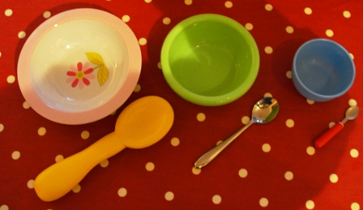

Can you remember how to make porridge?

