13 November 2020
Please complete the calculations below to find the sum of the 2 numbers. Complete as many as you can within 30 minutes then have a go at 2 of the challenges.
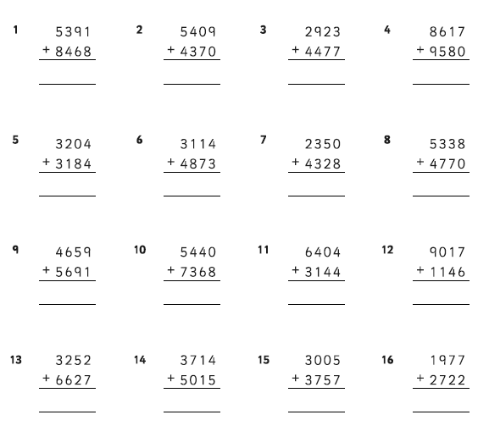
Challenge:
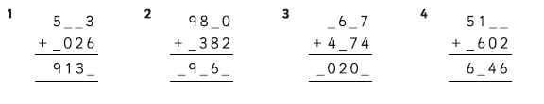
Super Challenge: Complete these magic squares. Every horizontal, vertical and diagonal line will equal the same number.
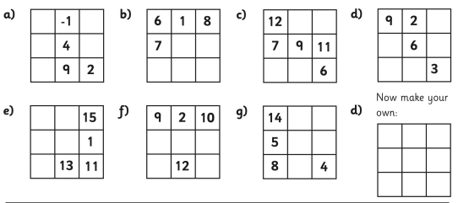
English
Please ensure your child is reading daily and practising the spellings on Purple Mash.
Today can you please complete the SPaG worksheet and edit your poem? Can you make at least 5 improvements now you’re looking at it with fresh eyes?

Science
In science this week we are building a solar system with the planets to scale with the earth. We can’t make a model with the distance from the sun to scale as Saturn, Uranus and Neptune wouldn’t fit in the classroom! If you can, have a go at making the entire model, but if you don’t have all the equipment try drawing and colouring the planets so they have the correct diameter. The arrow on the circle below shows the diameter.

PLANET | DIAMETER
Mercury | 0.8 cm
Venus | 1.8 cm
Earth | 2 cm
Mars | 1cm
Jupiter | 22cm
Saturn | 18 cm
Uranus | 8 cm
Neptune | 6 cm

You will need a pair of compasses to draw the circle, use a ruler to measure how wide they need to be set. Remember that it will need to be half the diameter, so a fiddly 0.4 cm for Mercury and a massive 11cm for Jupiter.
Draw the circles and colour them in appropriately.
Next take some cotton and using the compass point make a hole in the top of your planet and around the edge of a paper plate. Thread the cotton through the holes attaching the planet to the plate. If you make the string progressively longer for each planet the model will look more effective.
Draw another circle and colour it in to make your sun. Use the same method as above to fix the sun in the centre of your model.
I

