MOTORBIKES
How they work
The structure of a motorbike includes a petrol engine, which converts the motion of pistons (up and down) into rotary (circular) motion, just like the engine in a car. A transmission system transmits this motion to the back wheel. As the back wheel turns, it propels the motorcycle forward. The bike is steered by turning the handlebars which turns the front wheel and by leaning to one side or the other. Gears and brakes are controlled by hand levers each side of the handlebars and by foot pedals.
History
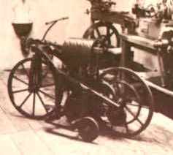
From the past . . . .
The first motorcycle was designed and built by German inventors Gottlieb Daimler and Wilhelm Maybach in 1885. This motorized bicycle, with a pair of stabilizers, was one of the first ever petrol-powered vehicles, and it was known as the Reitwagen, which means riding car.
. . . . to the present.
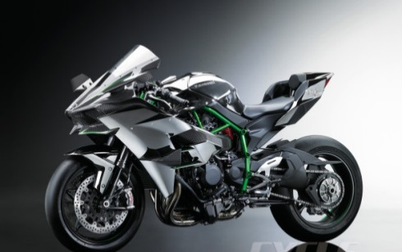
The new 2015 Kawasaki Ninja bike has 300 horsepower and is set to have a top speed of some 270 miles per hour! You may think this is a racing bike; however, aside from “the kind of acceleration no rider has ever experienced before”, Kawasaki want this bike to be an all-round bike with “stability and performance”.
The Law
In order to obtain a full licence to ride any motorbike, a theory test must be passed, a Compulsory Basic Training Course taken and two practical test modules also must be passed. Thirty motorcyclists are killed or injured every day at junctions, but despite these facts, the only compulsory protective gear is a helmet (except for Sikhs wearing a turban who do not have to). Experienced riders will say “all the gear all the time” and novice riders should pay attention to this. Coming off a bike at 70 mph and sliding along a tarmac road will break numerous bones as well as slicing strips of skin from all exposed parts of the body causing severe scarring – if the rider is lucky enough to survive. Full leathers – jacket, trousers, boots and gloves – are advised for riding even the smallest of bikes.
Interesting Facts
A feeling of complete freedom is often given as the reason for loving motorbikes though the convenience factor should not be ignored; eight motorbikes can park in the same space as one car and a bike can often wiggle its way carefully through a long traffic jam.
Motorcycles are often used for display purposes, their daredevil riders showing great skills with death-defying stunts.
- The fastest ever wheelie – when a motorcycle is pulled up onto one wheel – was performed at 105 mph.
- Ten motorbikes supported a record pyramid of 201 men in India in 2001.
QUESTIONS
- Pistons move . . in a circle left to right up and down Circle 1 (1)

- Give the two ways you can control brakes on the motorbike. (2)

_____________________________________________________________________

- What year was the motorcycle invented? Circle 1 (1) 1985 1885 1888 1855

- Why does the author write must in bold in the paragraph headed The Law? (1)

- What protective gear is recommended for riding a motorcycle? (2)

- Why is “all the gear all the time” written in inverted commas? (1)
______________________________________________________________________
- Who are exempted from wearing a helmet? (1)
_____________________________________________________________________
- What figure of speech is ‘ slicing strips of skin . . . causing severe scarring’?

_____________________________________________________________________
- What is convenient about riding a motorcycle? (2)
________________________________________________________________________________________
- How many motorbikes were involved in the record breaking pyramid? (1)

_____________________________________________________________________

- What kind of text is this and how does the writer make it easier to read? (3)

_____________________________________________________________________

_____________________________________________________________________

Answers

- Up and down
- Hand levers and foot pedals
- 1885
- Emphasis –to make it stand out – so the reader sees it – important point
- Helmet, trousers, jacket, gloves, boots 2 pts for 4+ 1 pt for 2+
- It is what experienced writers say – speech – quote
- Sikhs wearing a turban do not accept Sikhs
- alliteration or sibilance
- Parking and wiggling through traffic jams
- 10
- Information text sub headings pictures bullet points 1 mark for each to 3

