Date: | LO: Recall and use equivalences between simple fractions, decimals and percentages.

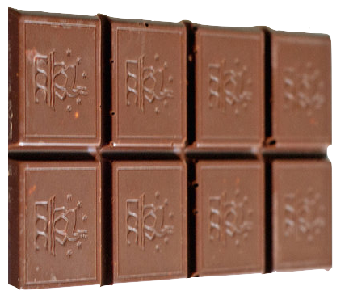
Write decimals and percentages on flash cards and have them face down.

In pairs, turn one over at a time.

The first person to write down 5 equivalent fractions to the decimal/percentage wins a point.
Three friends were competing in a race.

- Billy completed half of the race.
- Harrison completed 50% of what Billy completed
- Charlotte completed 0.25 of what Billy completed.

What fraction of the race did they each complete?
Tom and Sam shared equally one quarter of a chocolate bar.

What percentage of the chocolate bar did each child get?

Write the fractions (in simplest form) and percentages that equivalent to the following decimals:
1. 0.65 2. 0.4 3. 0.32 4. 0.95 5. 0.125 6. 0.02

Last month Kira saved ³/₅ of her £10 pocket money.
She also saved 15% of her £20 birthday money.

How much did she save altogether?
Explain why the pattern has formed.
Sharif says:

“All you do when converting percentages to decimals is put ‘0.’ in front of the number e.g. 78% is 0.78.”

Do you agree? Prove it!
Which is the odd one out?

²/₅ ⁴/₁₀ ³/₆ ⁶/₁₅ 0.4

Explain why.
Put the following numbers into groups:

³/₄, ³/₂, 0·5, 1·25, ³/₈, 0·125

Explain your choices.
Reasoning
Problem Solving
Fluency

