Monday 16th November

**Maths**

Warm up your maths brain by finding two dice, choosing a times table. Throw the dice and multiply the number on the dice by your chosen table. Then complete as many of these calculations as you can in 30 minutes.

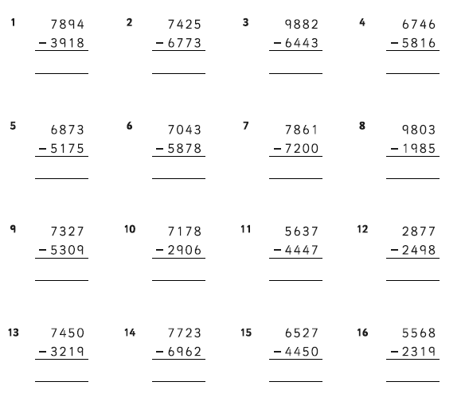

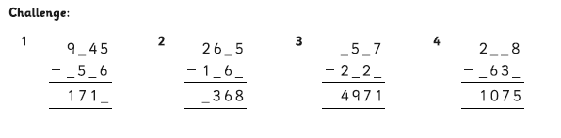

For writing today I’d like you to look at Psalm 8. Please write a short paragraph outlining what the Psalm means. How do you think it influences Christian beliefs about how we look after the world? Please draw a picture that you feel would illustrate this Psalm well.

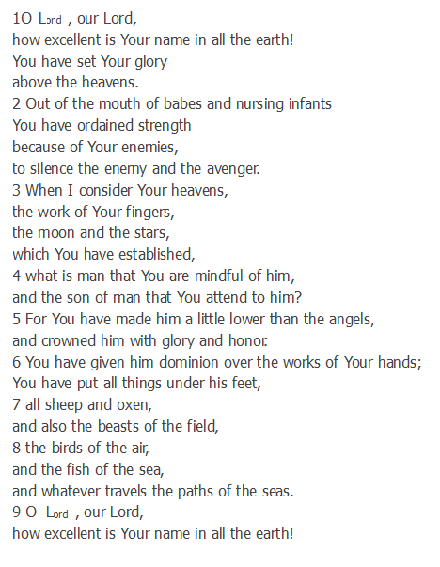

In Topic we watched the SpaceX launch. This was very exciting as we saw how the astronauts prepared for their flight and just how many people are involved in a rocket launch. We then continued our research on animals and people in space. Please research and answer the following questions.

1. Who was the first person in space and when did they fly?
2. Which countries invested the most time and money in to space exploration?
3. Who was the first man on the moon, when did this happen and who is he?
4. Please write a short paragraph outlining why you think humans explore space and what you would like to investigate if you were an astronaut.