Tuesday 17th November 2020
Maths
Below are 3 sets of questions. Choose the set of questions that you feel confident you can answer.
Set 1
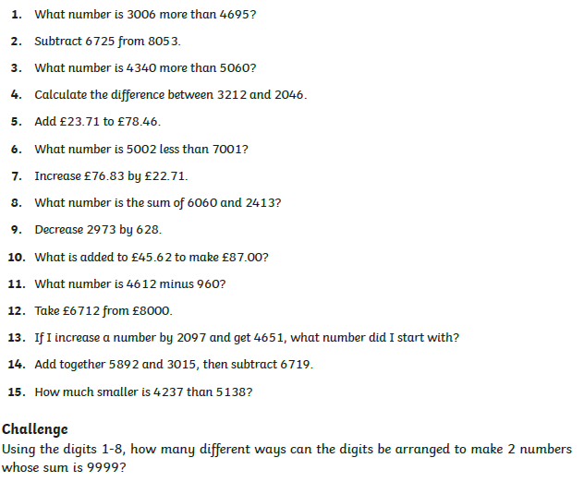

Set 2
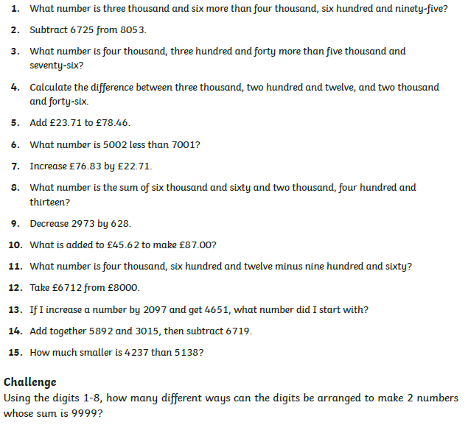

Set 3
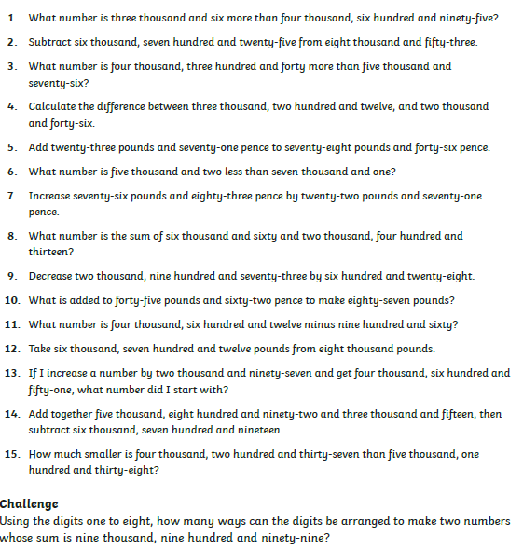

Spellings
Remember to look carefully first, cover then write and check your answer.
You can also access the spellings on the Purple Mash website.
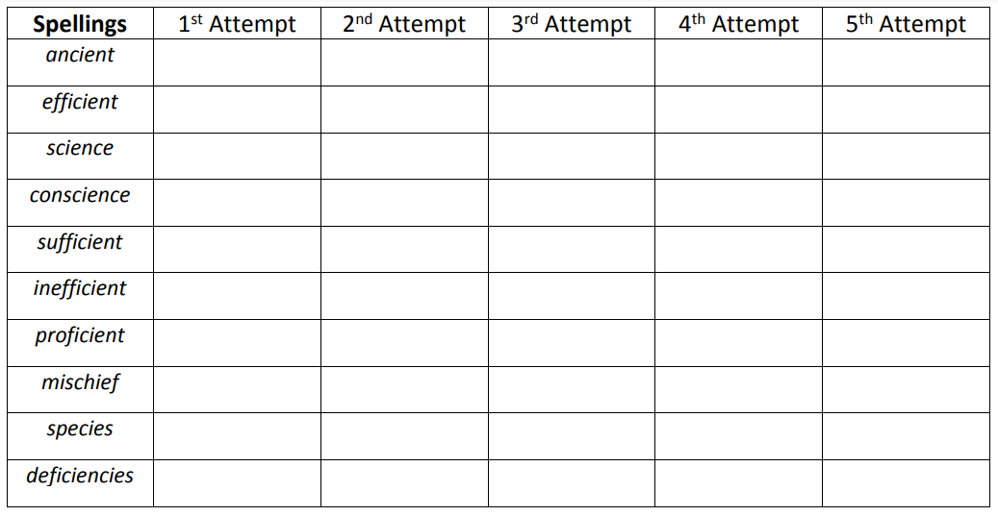

Writing
Please edit your work from yesterday and make at least 5 improvements.
Reading
Read for at least 10 minutes per day and remember to keep your reading records updated.

