Wednesday 18th November 2020
Maths
Below are some more word problems. Please use column method to complete the calculations, or see below it for a more challenging maths activity.
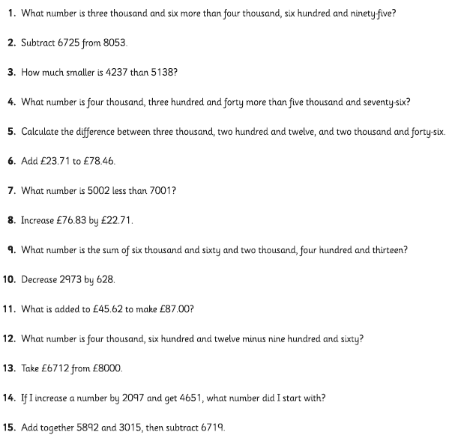

Challenge
This is a 4 x 4 Magic Square made from the numbers 1 to 16.
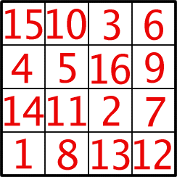
In a Magic Square all the rows, columns and diagonals add to the same number. This number is called the 'Magic Constant'.
Here are some questions about this Magic Square.
1/What is the Magic Constant of this Magic Square?
This particular square is especially 'magic' as some 2 x 2 squares within it also add to that number.
2/How many of these squares can you find?
3/What happens to the Magic Constant if you add 2 to each number in the square?
4/What happens if you double each number?
5/Can you make a square in which the Magic Constant is 17?
How did you do it?

6/Can you make a square in which the Magic Constant is 38?
How did you do it?
7/What other numbers under 100 can you make into the Magic Constant by changing all the numbers in the square in the same way?
8/Can some be made in more than one way?
9/Are there some numbers you really cannot make?
Answers to yesterday’s questions
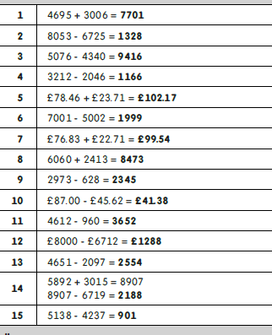
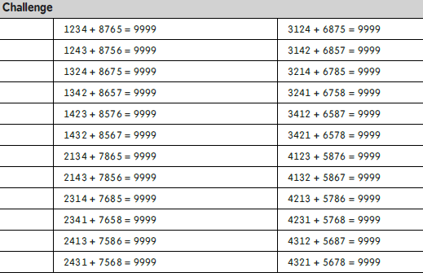

Art
In art we are looking at Peter Thorpe and his space art. Can you research his work at home and draw a picture influenced by some of his ideas? Look closely at his use of colour and shading.

