Home Learning
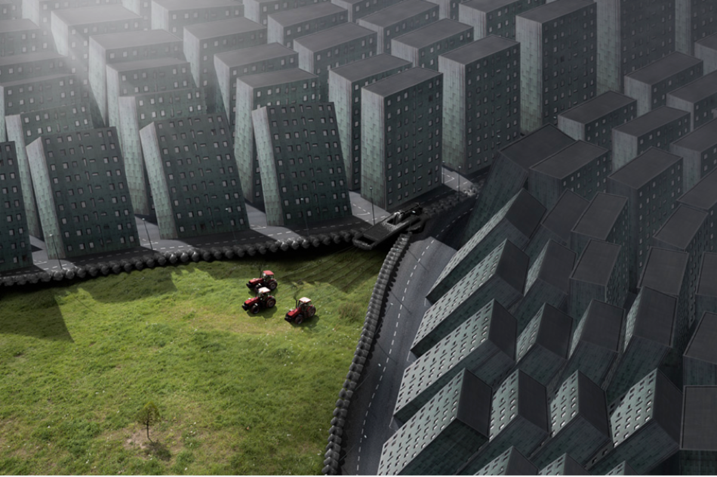
English: Look at the picture below and answer the questions underneath. These are all your own thoughts. Please give evidence from the picture for your answer.

Questions:
- Do you think technology is a good think or a bad thing? Can it be both?
- Would you rather live in a city or in the countryside?
- What can we do in the future to look after our planet? What do you do already?
- If you could ask the world a question, what would it be?

