Home Learning
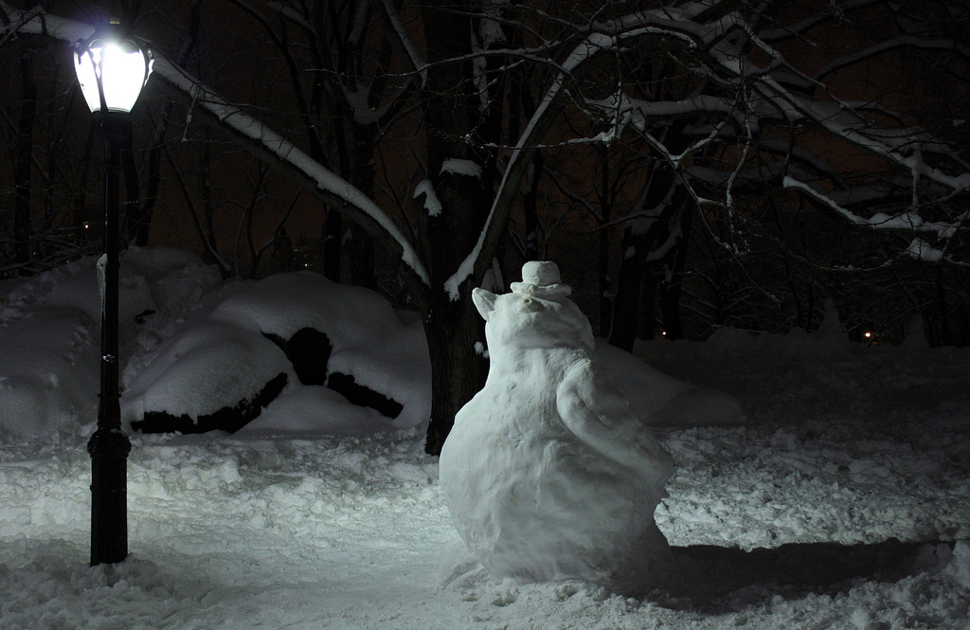
English: Please look at the picture below and write a paragraph about it. Please use the questions below to help you make your paragraph.

Questions: Think about these questions to help you with your paragraph.
- What you can feel under your feet?
- What you can see?
- What you can hear?
- What the weather is like?
- Your footprints?

Please write your paragraph on the lines below or on lined paper.

