Home Learning
Maths: Today we are going to be looking at subtracting 2-digit numbers.
Please watch the video to help you: https://www.bbc.co.uk/bitesize/topics/zy2mn39/articles/zc78srd

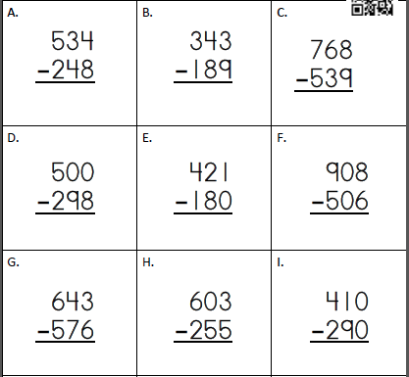
Questions:

