Home Learning
Maths
Today, we are going to do the 2x table. Please watch the video below and sing along to the 2x table.
Video: https://www.youtube.com/watch?v=8hN9Ur_xdm0
Below there are some activities to complete on the 2x table. Please have a go at each one. There are also some challenges.
1.

2.

3.

4.

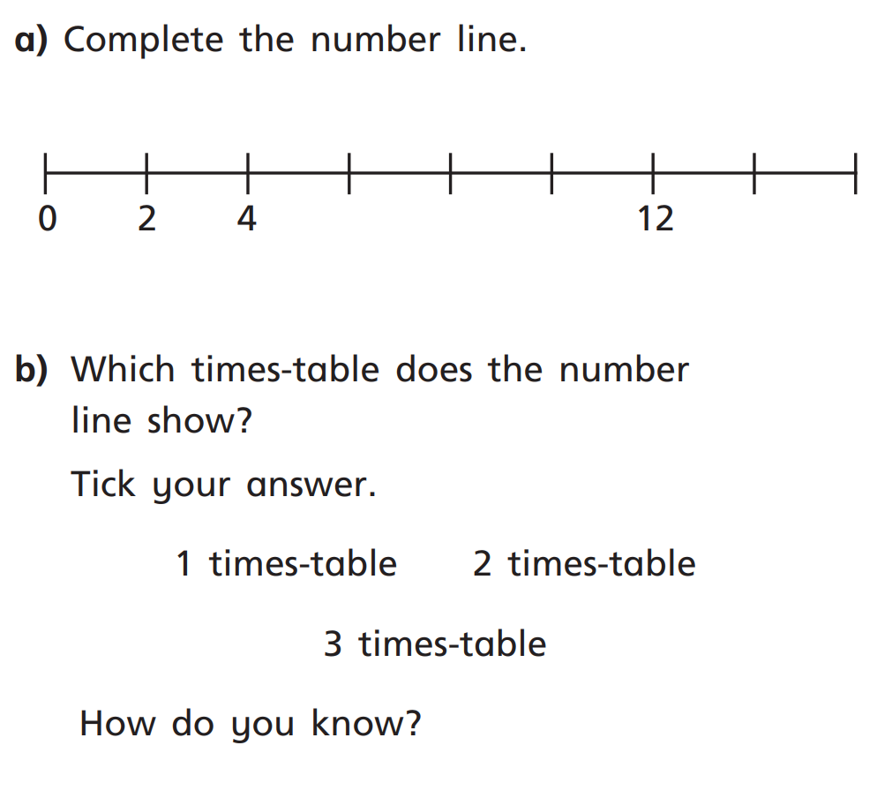
Challenge:

