**Home Learning**

Year 1 and 2 English

Please look at the picture below and use the word bank to help you write some sentences about the castle.

Questions to think about:

1. Who lives in the castle?
2. What could harm the castle?
3. Can you describe the surroundings of the castle?

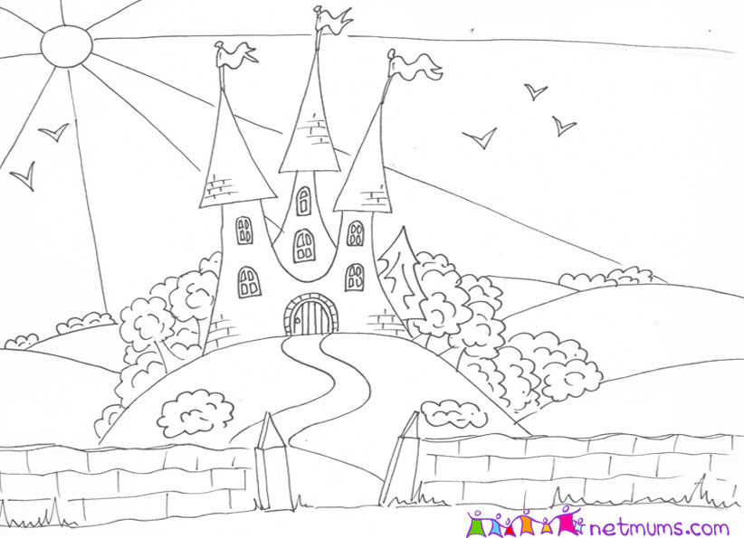

castle

prince

princess

knight

dragon

turret

tower

___________________________________________________________________________________________________________________________________________________________________________________________________________________________________________________________________________________________________________________________________________________________________________________________________________________________________________________________________

I leave finger spaces between words.

My sentences start with a capital letter.

My sentences end with full stops. 

My sentences make sense.