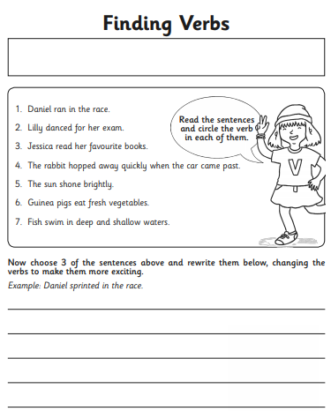
Task: Complete Set 1 or Set 2 (Set 2 is more challenging).
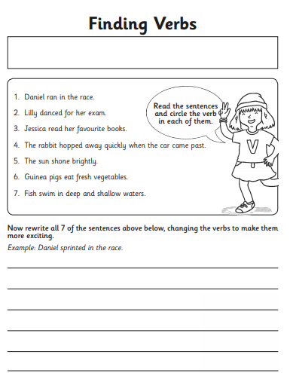
Set 1 Set 2

