Homework:
Year 1 and 2:
English
Please look at the picture below. I have written a simple sentence underneath and I would like you to have a go at making it more exciting by adding adjectives.
I have done the first one for you to show you how to do it.
Remember: An adjective is a word that describes a noun.

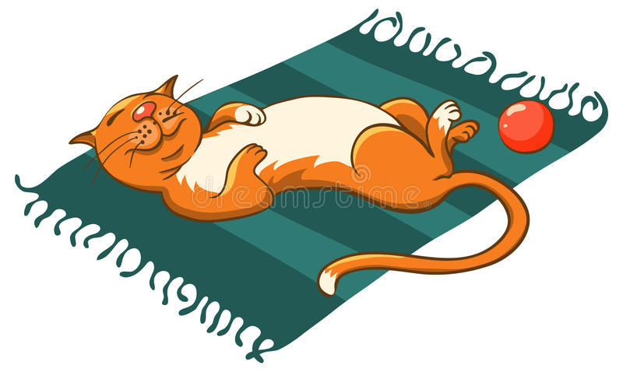
My sentence: The cat is on the mat.
Sentence using adjectives: The ginger cat is sleeping on the stripy mat.

Can you see the difference?

Now it is your turn:
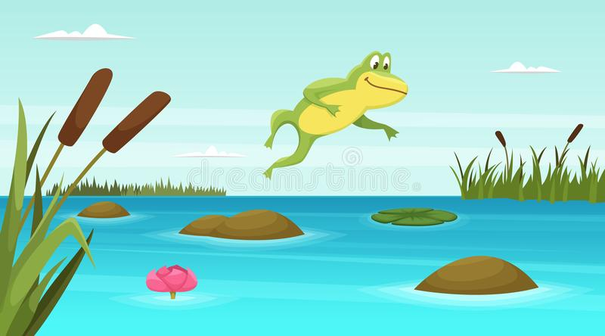
1.

My sentence: The frog is at the pond.
Your Sentence: _________________________________________________________________________________________________________________________________________________________

2.

My Sentence: The dog is running.
Your Sentence: ____________________________________________________________________________________________________________________________________________________________________________________________________________

Year 1 Maths – 2D Shapes
Please look at the key on the left of the picture and colour in each shape in the correct colour. Some shapes are given, and on others, you are given a clue on what shape you need to colour.

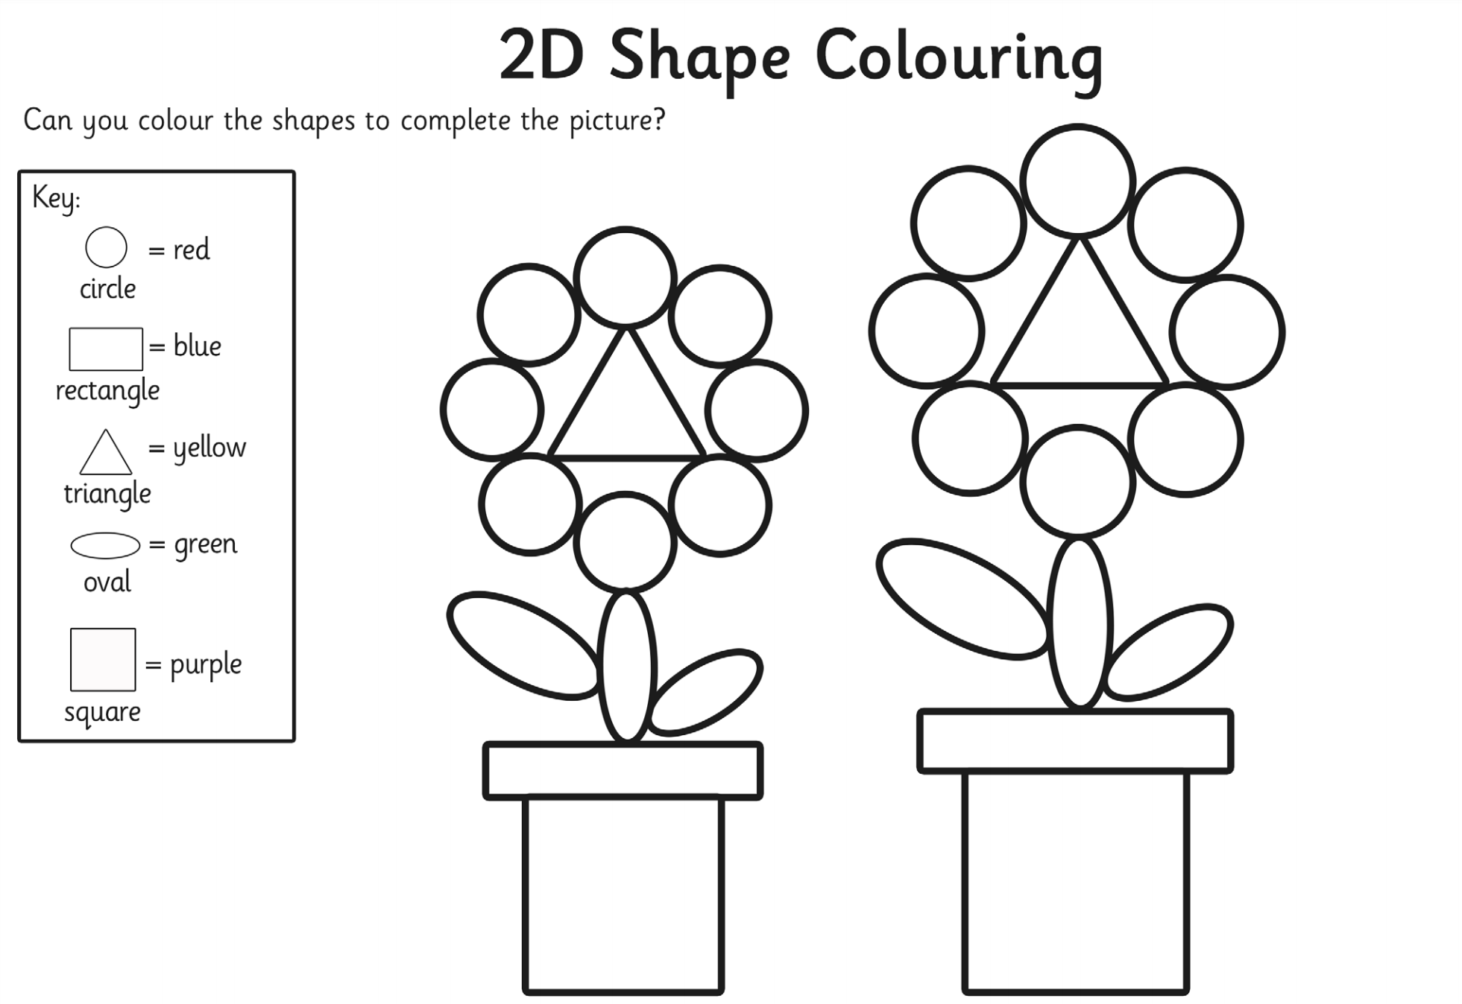
A shape with 3 vertices.
A shape with 4 equal sides.

