Maths - Wednesday 11.11.20
Solve questions from any two sections of your choice.
How to convert improper fraction to mixed fraction
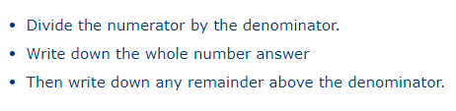
How to convert mixed fraction to improper fraction
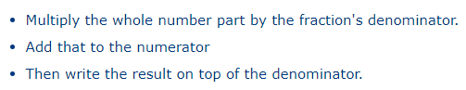
A
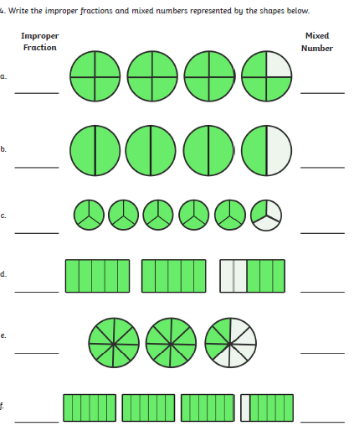
B
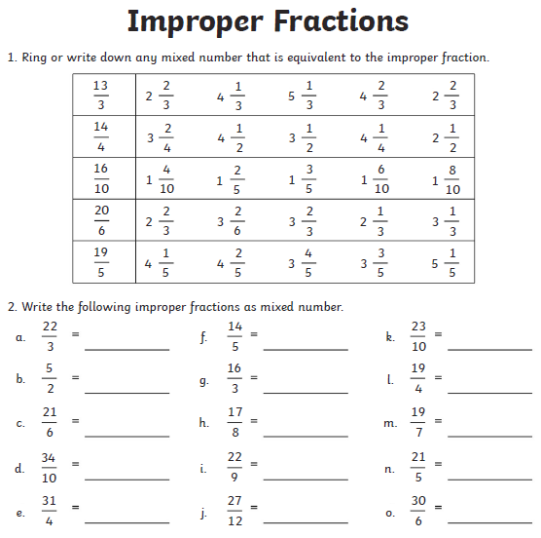
C
