Maths
Here are some questions and a challenge. The answers have been attached at the end. Don’t take a peek, solve the questions first!
Word problems
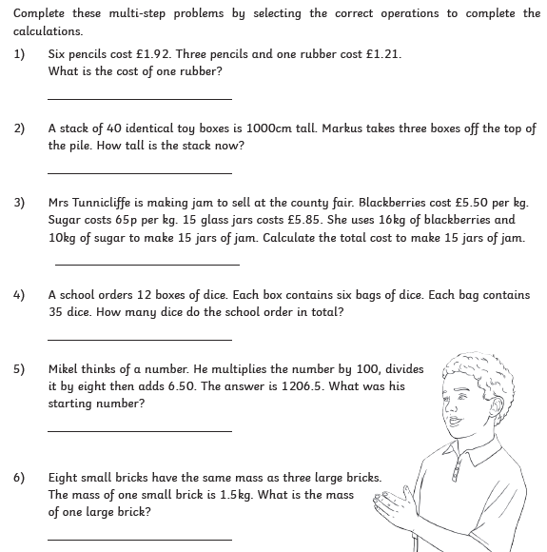
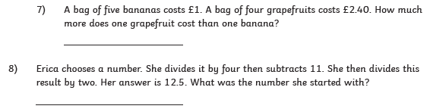

Challenge
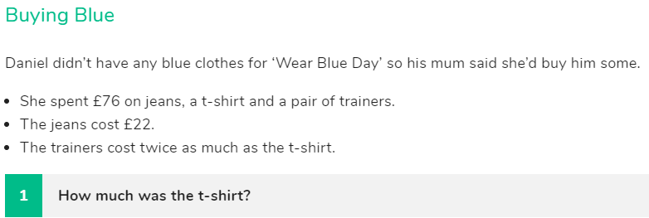
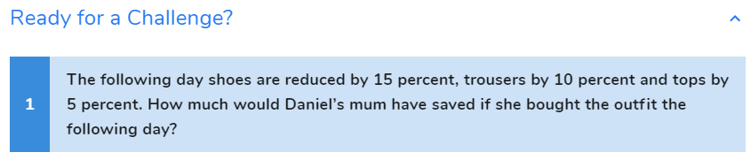
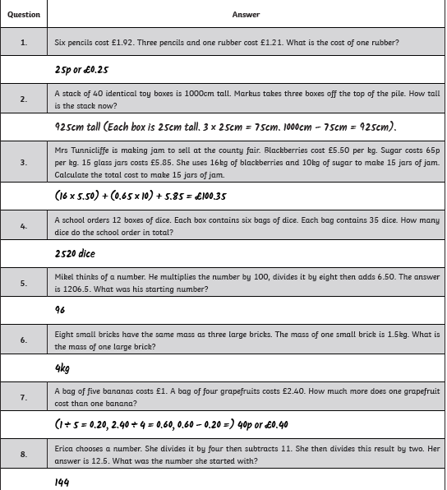

Challenge answer
T-shirt £18
Ready for a challenge answer £8.50

