Maths 18.11.20
Read the questions carefully and solve them. The answers are attached at the end for you to mark your work. If you get stuck, don’t spend too long on a question. You should move on and come back to the tricky ones once you are finished.

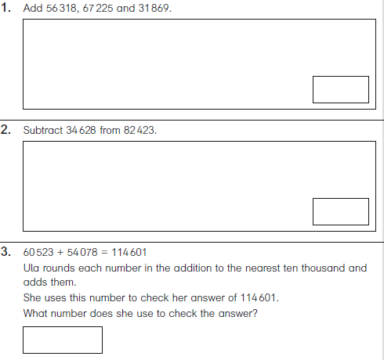
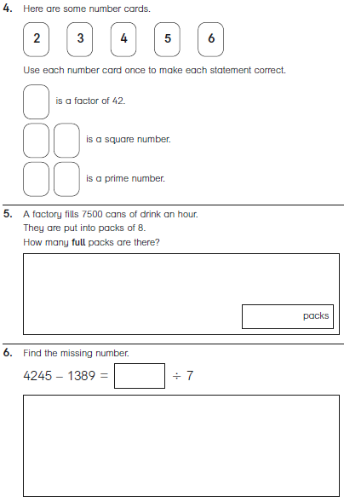

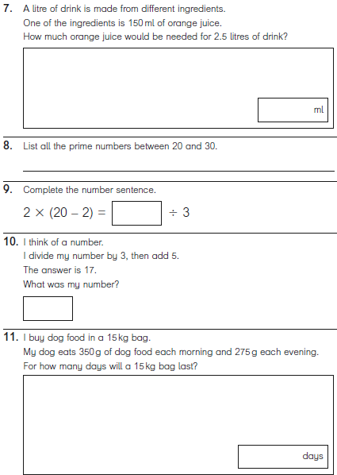
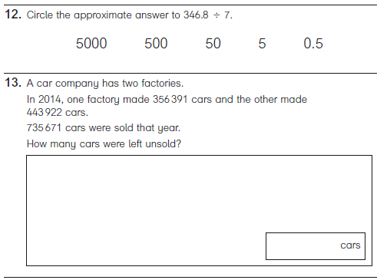

Challenge

ANSWERS
