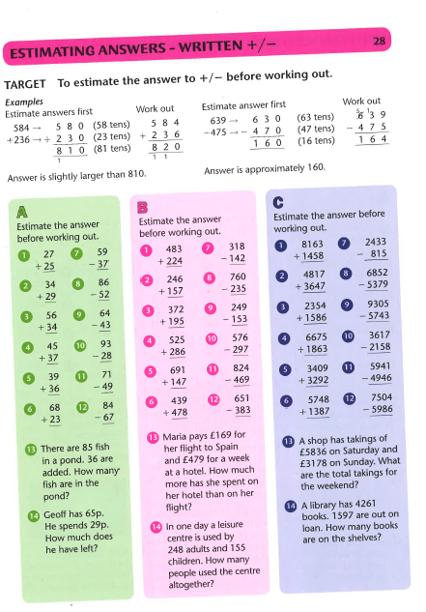
Choose one set of Maths questions and answer at least 6 of them. Make sure you choose the right level of challenge for you. Set C is the most challenging.
Have a go at one of the problem solving questions.

