LO: Can I multiply by 5?
Task:
- Complete set 1 or set 2 (Set 2 is more challenging)
- Have a go at one of the problem solving challenges
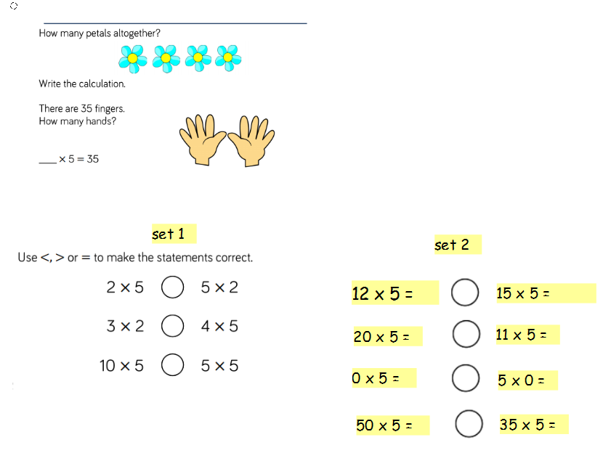

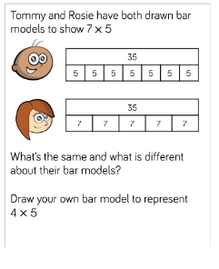
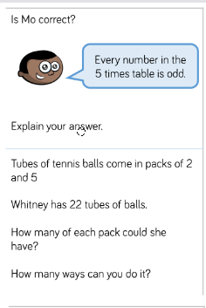
Challenges

