Home Learning
English
This term, we have been reading ‘The Paper Bag Princess.’ Please watch the video below to remind yourself of the story.
The Paper Bag Princess: https://www.youtube.com/watch?v=ZMFIyNuKhSc

We are going to focus on the Dragon. The Dragon has lots of different qualities. Please look at the photo below and write 3 sentences to describe the dragon. I have given you some sentence starters to help you.

Challenge: Try and add in some describing words to add to the description of the Dragon.

The Dragon:
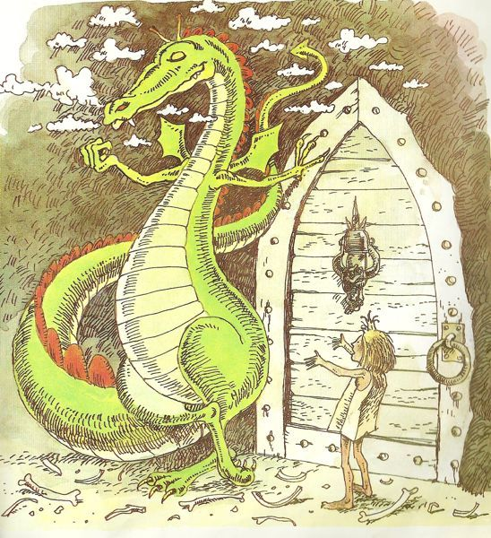

1. The Dragon has _____________ skin and a spikey __________ tail.

2. The Dragon ____________________________________
_______________________________________________
_______________________________________________.

3. The Dragon looked ______________________________________________________________________________________________

