**Home Learning**

**Year 1 and 2 English**

Year 1 and 2:

We are going to be reading a new book called ‘Supertato’ for the next few weeks to continue the topic of Heroes and Villains.’

Please watch the video of the story:

Please only watch up to 2:45 - <https://www.youtube.com/watch?v=QlaMeNmTG6c>

Before watching on, can you write a prediction about what you think is going to happen?

What do you need at the beginning of a sentence? What do you need at the end? What do you need in-between words?

A prediction is something you do when you are guessing what might happen next. In this case, you are predicting or guessing what might happen next in the story.

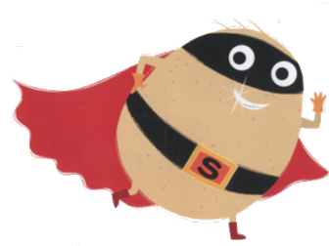Your sentence can start with…

I predict that…

Questions to help you!

1. What might happen to Supertato!
2. What might the evil pea do next?

Once you have written your prediction, you can watch the rest of the story to see what happens next!

Were you correct?

Is there anything you would change?