Home Learning:
Year 1 and 2 Maths
For the next week our new topic is Geometry. Please watch the following videos to help the children recap 2D shapes and 3D shapes.

2D Shapes: https://www.youtube.com/watch?v=OEbRDtCAFdU
3D Shapes: https://www.youtube.com/watch?v=2cg-Uc556-Q

Year 1 and 2:
Below there are some mixed up 3D shapes. Please match them to the correct name and the correct ‘real life’ object. If you are unable to print, please write the names and draw a picture of the shape.

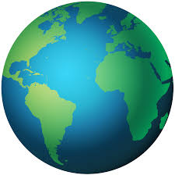
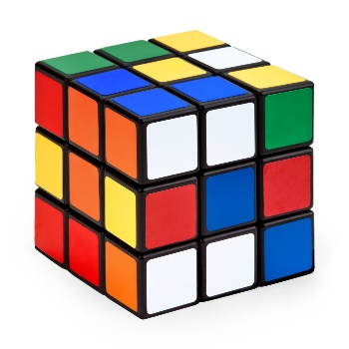
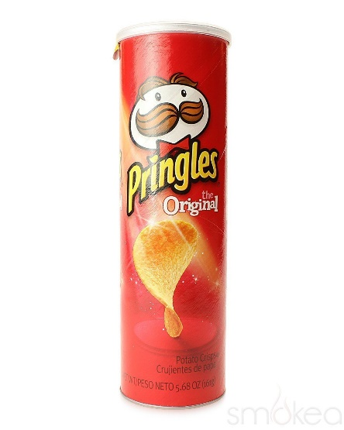

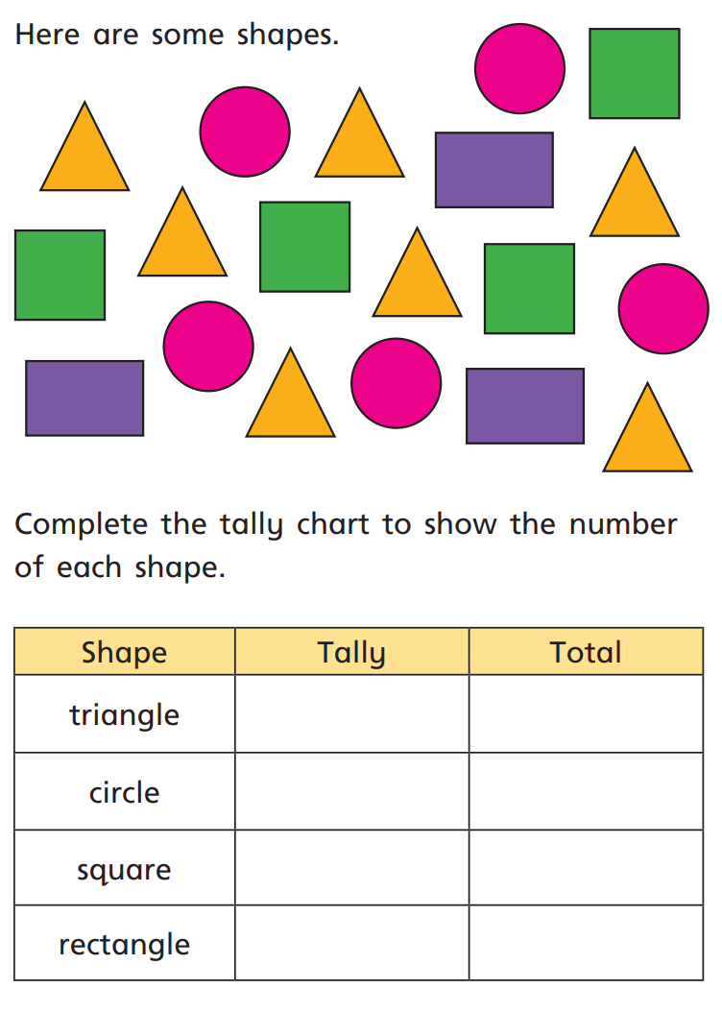
Year 2: This is to recap your knowledge
of 2D shapes. Can you count how many
there are of each shape?

If you are unable to print, please write
your answers on paper.

