Home Learning:
English – Tree Door
Below there is a picture with a story starter below. Please have a go at writing a description of what you think comes out of the doors.
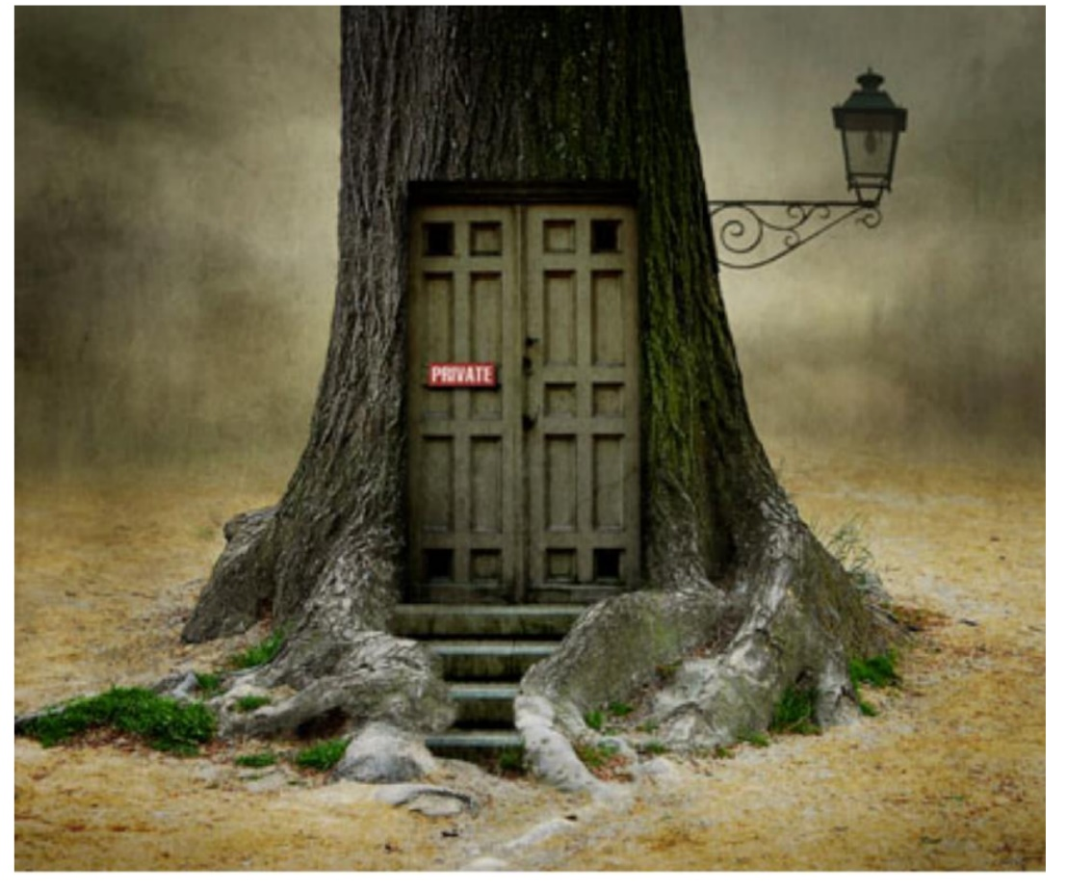

Story Starter:
The creaky, old doors had not been opened for years. The beast had always lived inside but nobody dared to visit. Noises that echoed from the gaps in the door had haunted those who heard them. Nobody knew what the narrow, mossy steps led to. Nobody knew what was lurking within.
One day, the heavy, wooden doors slowly began to groan…
What do you think happened next?

