Home Learning
Maths
Today we are going to be learning about converting fractions to decimals.
Please watch the video to learn about decimals: https://www.bbc.co.uk/bitesize/topics/zsjqtfr/articles/zsbd7p3

Now, please watch this video that will explain how to convert tenths and decimals: https://www.youtube.com/watch?v=yWcNQkmpYVk

Below there are some questions that look at converting tenths and hundredths to decimals. Have a go at matching the fractions to the correct decimal.

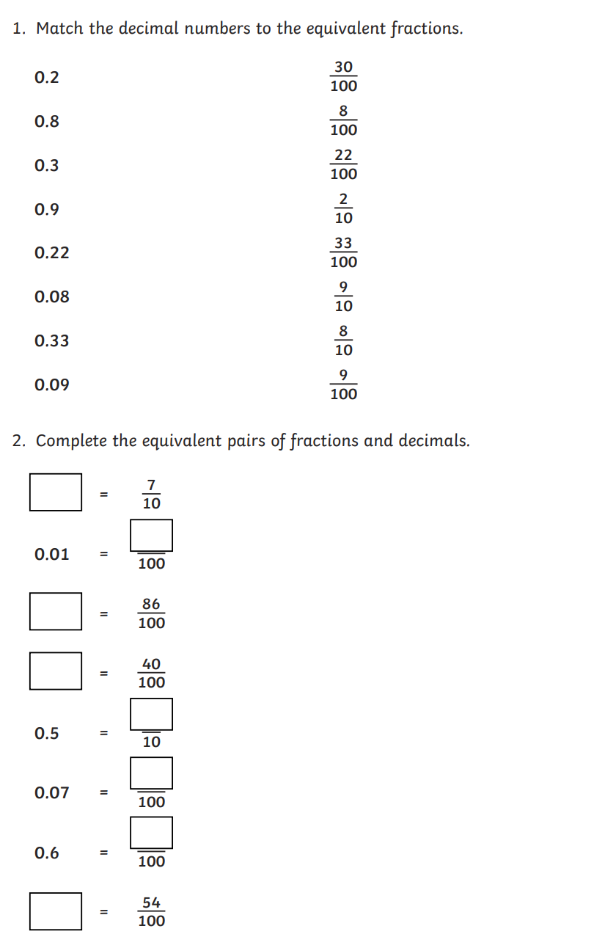
Questions:

