Owls Home Learning:
Maths: Fractions. Please look at the questions below for adding and subtracting fractions with the same denominator.
Watch this video to help you: https://www.bbc.co.uk/bitesize/topics/zhdwxnb/articles/z9n4k7h
- There are also activities and games to have a go at underneath this video.

Adding Fractions: Please complete these questions on this page or on paper.

5.
1.
8.
7.
6.
4.
3.
2.

Subtracting Fractions: Please complete these questions on this page or on paper.
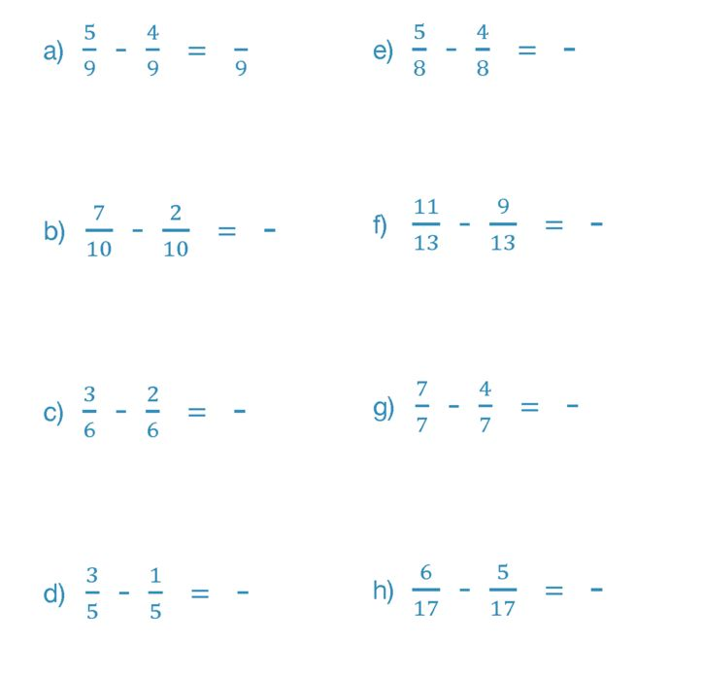
8.
7.
6.
5.
4.
3.
2.
1.

