RE

Here are some ‘What would Jesus do’ artefacts that we have looked at in class. We discussed these are popular because Christians want to follow Jesus and apply His teachings to their life.
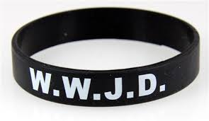

Can you now challenge yourself to design one of your own? Remember it should be a small item that can be used in everyday life and has the initials WWJD along with its meaning.

