Science
Play this cool game.
https://www.sciencekids.co.nz/gamesactivities/howwesee.html
When you visit the above link, you will see the message below. Click on ‘OK’ to get started!
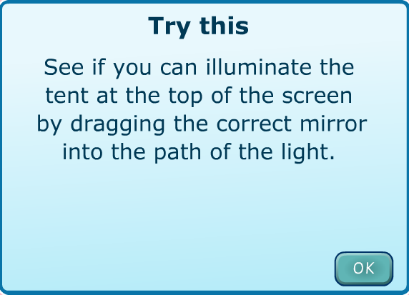
When you finish the first level, the second will challenge you to change the mirror angles to see which way they reflect the light. Keep persevering until you reach your goal. Have fun!

