Home Learning
Year 1 and 2 English
We have been reading the story of ‘Supertato’ this week. Let’s look at Supertato himself. Answer the questions with your adult.
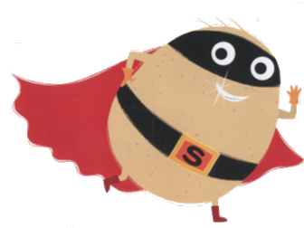
Questions
- What colour is his cape?
- What is he wearing on his eyes?
- What does his belt have on it?
- What would you change for your supertato superhero?

Today you are going to design your own ‘Supertato.’ Think about what Supertato is wearing and see if you can use the questions below to create your own Supertato. Once you have drawn your own ‘Supertato’ please write a paragraph describing what your new ‘Supertato’ looks like.
Below is the template to draw your design and some lines for your writing. If you are unable to print this page, please draw your design and do your writing on some lined paper.

Supertato Template:

Questions
- What colour is his cape going to be?
- What colour is his mask?
- What is his belt going to have on it?
- What would you add or take away on your Supertato?

___________________________________________________________________________________________________________________________________________________________________________________________________________________________________________________________________________________________________________________________________________________________________________________________________________________________________________________________________________________________________________________________________________________________________________________________________________________________________________________________________________________________________________________________________________

