Squirrels Homework
Friday 13th November 2020
Year 1 – English
We have been studying the story of ‘The Paper Bag Princess.’ Have a think about Elizabeth and how her feelings change throughout the story. I have put 3 pictures below to help you with your ideas.
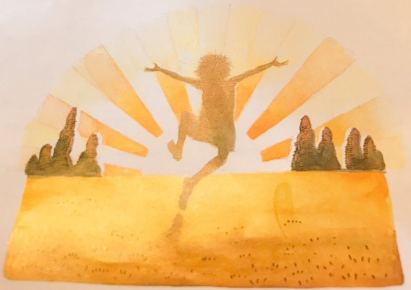
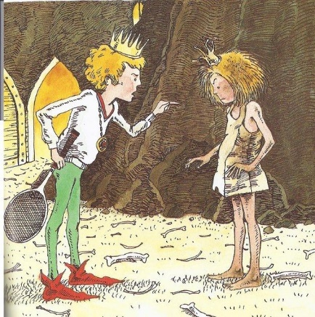
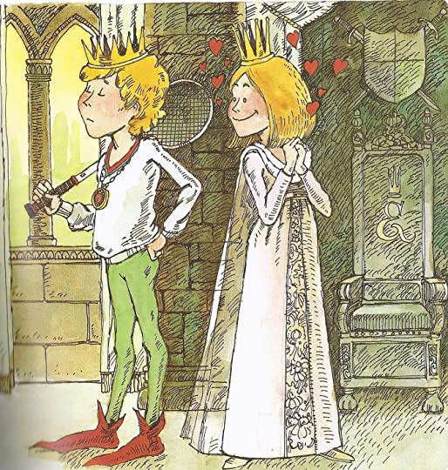

Write a sentence about each picture to see how her feelings change. Use the sentences starters to help you.
- In the first picture, Elizabeth feels…..
- In the second picture, Elizabeth feels….
- In the final picture, Elizabeth feels….

Year 2 – English
We have been studying the story of ‘The Paper Bag Princess.’ Have a think about Elizabeth and how her feelings change throughout the story. I have put 3 pictures below to help you with your ideas.

Write a sentence about each picture to see how her feelings change. Use the box of key words to help you with your sentences.

Key Words:
happy relieved upset
confused shocked sad
puzzled surprised loving

Year 1 – Maths
Finding the Difference – Look at the following questions. Remember, you have been given one of the part numbers, so count that number of objects and then count the remaining numbers to see the answer.
1. Find the difference between: 13 and 7
7 + ____ = 13

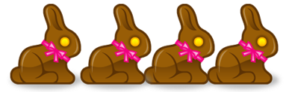
2. Find the difference between 15 and 9
9 + ____ = 15

3. Find the difference between _____ and 3
3 + ____ = 14

Comparing Number Sentences – Workout the number sentences and use the correct sign to compare them. Remember, the gator always eats the biggest number. Use <, > or = to fill in the circles.
1. 3 + 2 = _____ 6 + 4 = _____

2. 4 + 2 = _____ 2 + 7 = _____

- 1 + 3 = _____ 3 + 4 = _____
Year 2 – Maths
Subtracting two 2-digit numbers crossing ten. Remember to knock next door to the ten’s column!
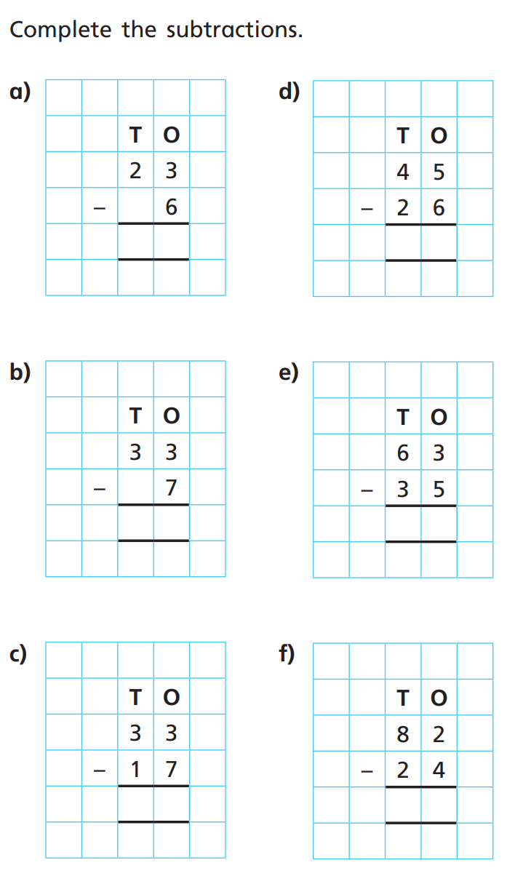

Adding three 1-digit Numbers:
1. 3 + 6 + 2
2. 6 + 4 + 5
3. 5 + 5 + 2

Challenge: Use <, > or = to compare this number sentence:
7 + 3 + 4 = _____ 8 + 2 + 7 = ______

