Home Learning
Maths
Year 1
Please look at the numbers below and make them in the tens frames beside them. If you are unable to print, please write the number on paper and represent the number next to it using circles.
15
18

20
12

We are going to look at one more, one less today. Please use the Word Mat below to help you with your numbers to 20 and fill in the sheet below.
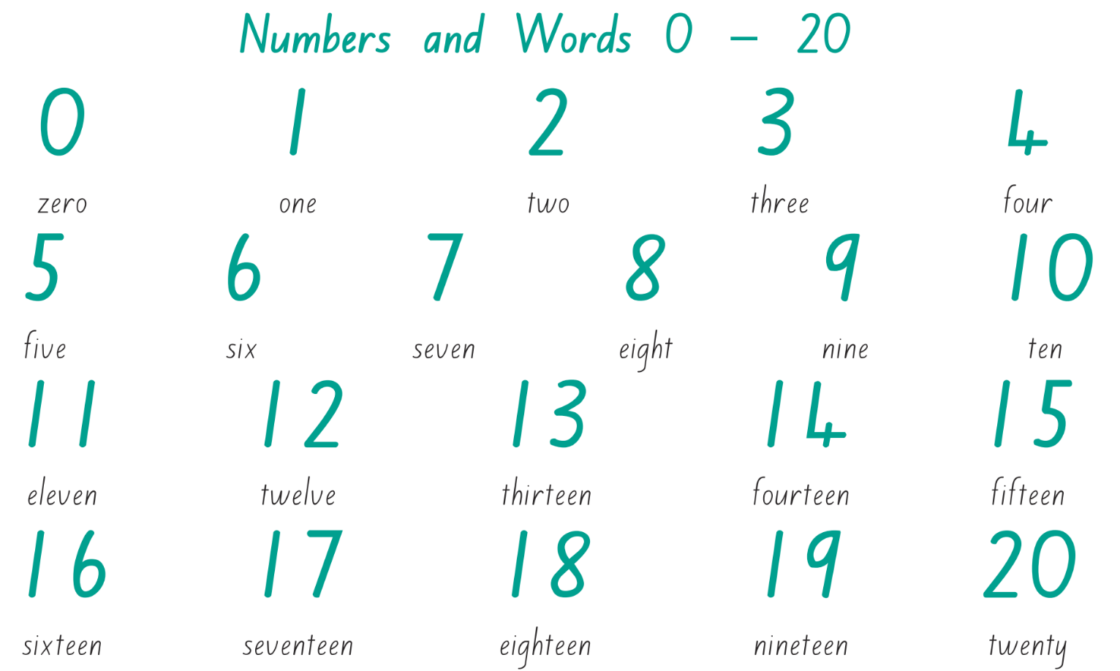

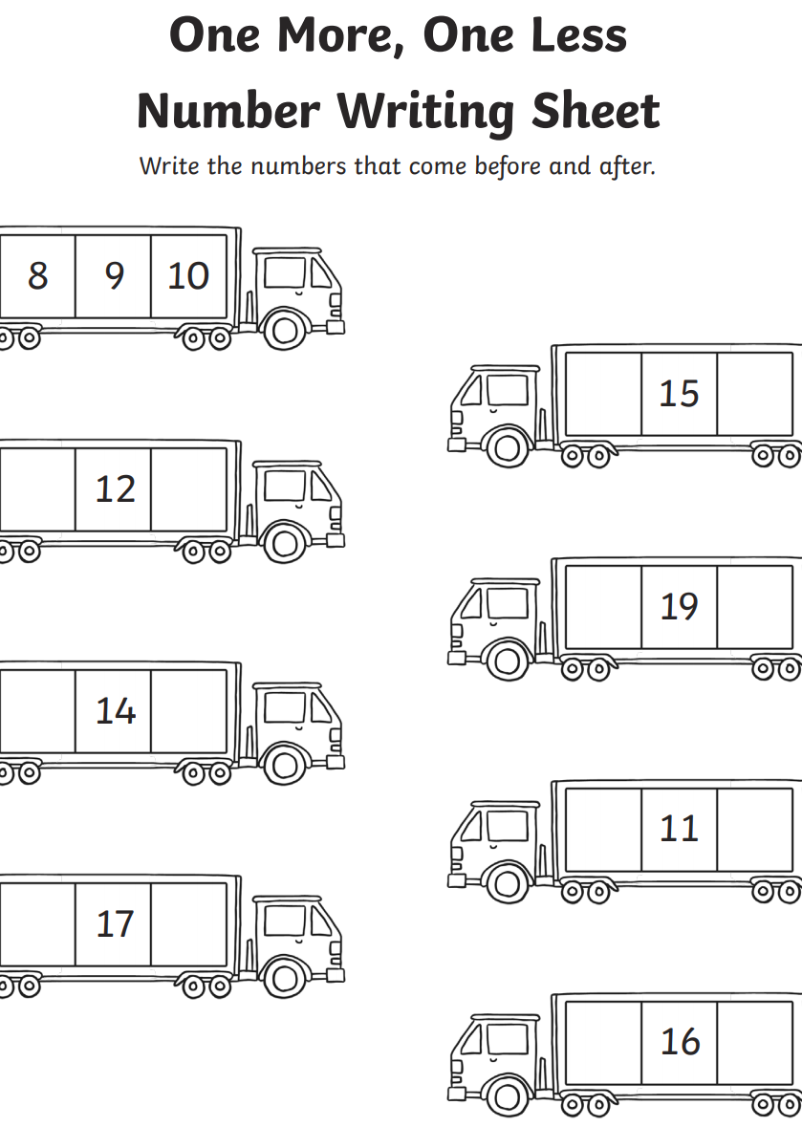

Year 2:
Today we are going to do some recap work. We are looking at adding a 2-digit and a 1-digit number together crossing 10.
Please complete the first questions below using the number line provided. If you are unable to print, please write the number sentences and the answers below.
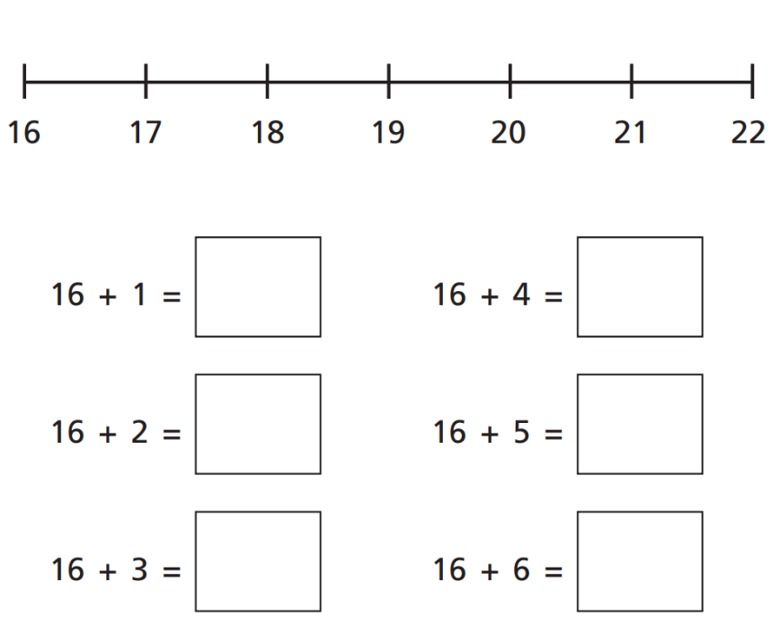

Watch this video on Partitioning and then answer the questions on the next page:
https://vimeo.com/465863014

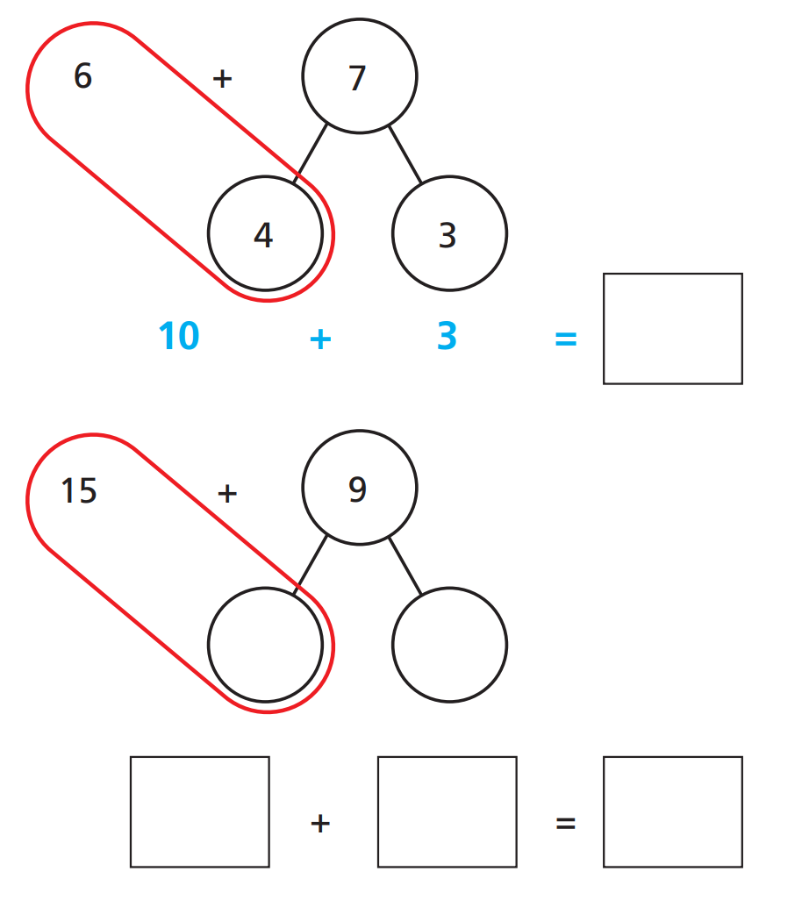
Questions:

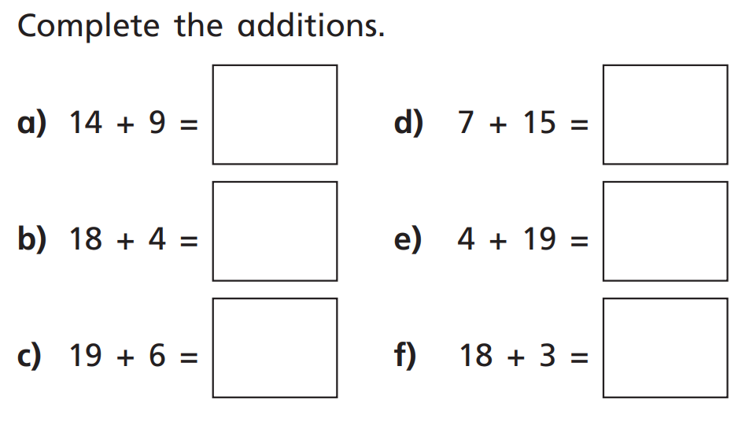
Extension Questions: Please use the method from the video to answer these questions.

