Home Learning
Year 1 and 2 Maths: For todays home learning, please sort the 2D and the 3D shapes into the correct sections. If you are able to print this off, please cut and stick the shapes into the correct sections. If you are unable to print, please split a piece of paper into 2 and write the names of the shapes into the correct section.
2D Shape Video: https://www.bbc.co.uk/bitesize/topics/zjv39j6/articles/ztpwdmn
3D Shape Video: https://www.bbc.co.uk/bitesize/topics/zjv39j6/articles/zcsjqty
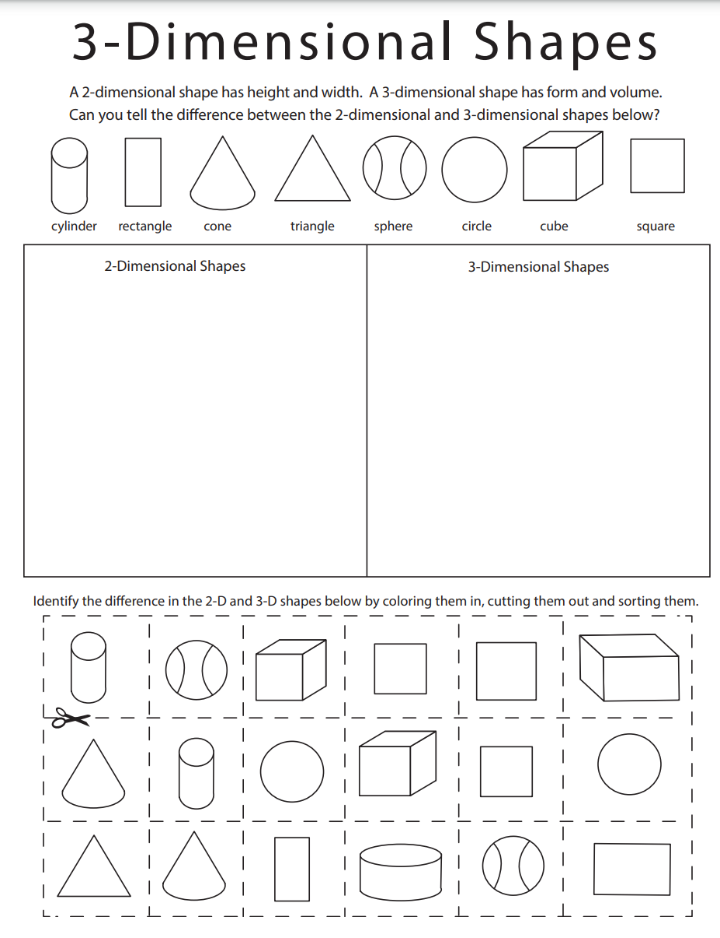
Activity:

