Hello!
Firstly, can I say how well all you Badgers have done with more regular reading at home. We can really begin to see an improvement in your confidence when reading aloud and in your writing! Excellent work everyone!
Homework for the week as follows:
Please have a go at your spellings (if you’re in my spelling group this is for your test on Monday, if you’re in Mrs Hodson’s feel free to use these spelling too) on Purple Mash. Practise them using the look:cover:write method too.
Science
Further to our science lesson on phases of the moon, please look at the night sky five times this week, draw the shape of the moon and label correctly as a waxing gibbous, waning crescent etc. Remember a waxing moon follows a new moon as we are beginning to see more of the moon and a waning moon follows a full moon as we begin to see less.
English
Please complete these sentences by adding a phrase to give extra information.
- A gentle breeze blew
- It was a delicious picnic
- Throughout the day the class
Please use these phrases to write your own sentences.
- after the warm spring rain
- a river that glistened in the moonlight
- crossing the sea under a blazing sun
Maths
Please complete at least 3 of the questions below. The questions gradually become more challenging so choose ones you are confident you can answer.
1) What is the perimeter of a square with sides of 5m? Write your calculation down too.
2) What is the area of a square with sides of 5m? Write your calculation down too.
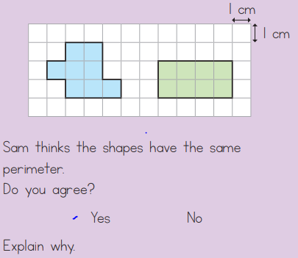
3)

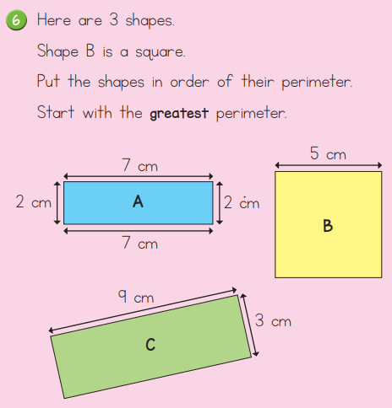
4) Please do the same for their area.

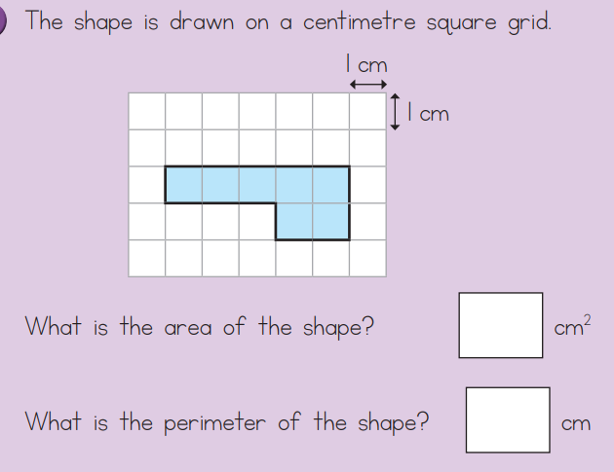
5)

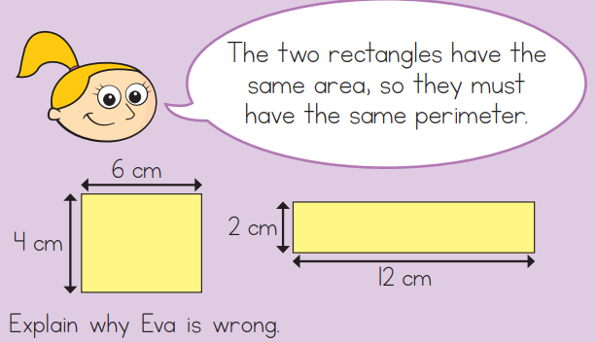
6)

7) Once you’ve worked out the missing dimensions please work out the area and perimeter of this rectilinear shape.
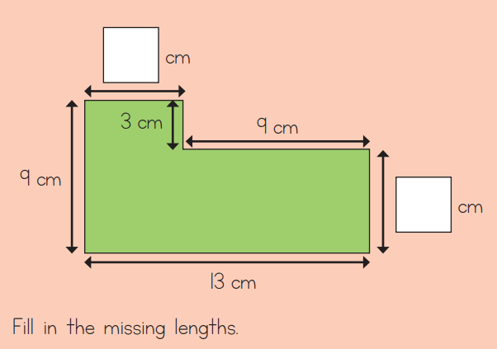

8) 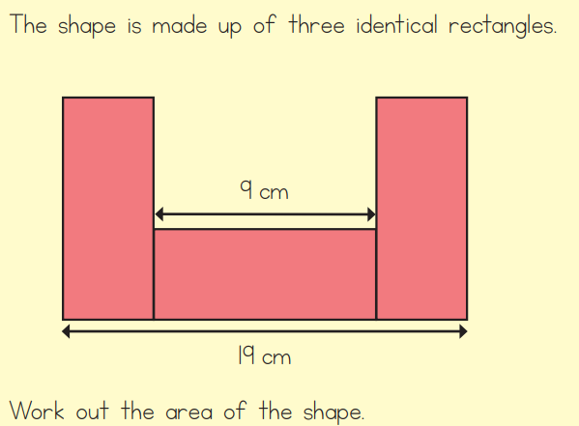
9) Fill in the missing dimensions to work out the perimeter and area of the shape below.
