Home Learning
Year 1 and 2 Maths
Year 1: This week, we are focusing on Shape. Today we are going to be sorting 2D shapes. Have a look at the shapes below and see if you can sort them into 3 different groups.
If you are unable to print this off, please split a piece of paper into 5 and draw the different shapes into the different groups.
Challenge: Have a go at writing on the line above each group what shape is in that group.
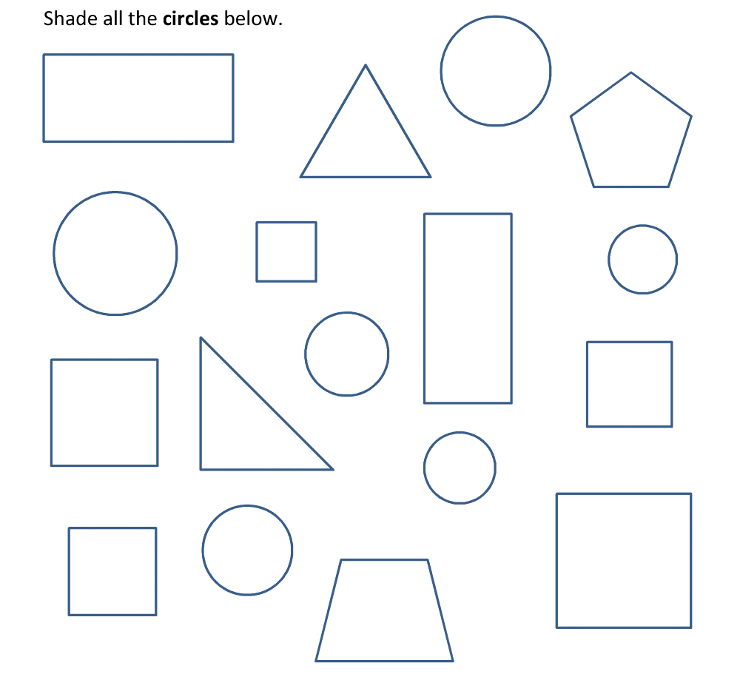

Year 2: This week, we have been learning about shapes. We are now going to look at counting how many vertices there are on a shape.
Vertices: Where two sides meet to form a corner on a 2D shape.
Below there are some different shapes, can you write how many vertices there are? If you are unable to print this off, please write the answers on a piece of paper.

Challenge:

