Home Learning
Year 1 and 2 English
Re-watch the story of ‘Supertato’ - https://www.youtube.com/watch?v=QlaMeNmTG6c

Think about Supertato and the Evil Pea. We are going to be writing some sentences to describe them. Can you think of the word we call describing words?
Adjectives – https://www.bbc.co.uk/bitesize/topics/zrqqtfr/articles/zy2r6yc

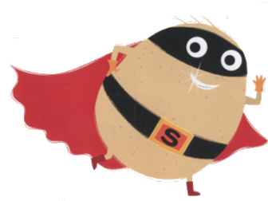

Choose one of the characters above and have a go at writing some sentences using adjectives. I have given you an example below.

Supertato has a long, red cape.

Now it is your turn!
I have given you lines below to write on, but if you are unable to print, please write the name of the character you are writing about and write your sentences on paper.
Supertato:

1. _________________________________________________________________
_________________________________________________________________
_________________________________________________________________

2. _________________________________________________________________
_________________________________________________________________
_________________________________________________________________

3. _________________________________________________________________
_________________________________________________________________
_________________________________________________________________

4. _________________________________________________________________
_________________________________________________________________
_________________________________________________________________

The Evil Pea

1. _________________________________________________________________
_________________________________________________________________
_________________________________________________________________

2. _________________________________________________________________
_________________________________________________________________
_________________________________________________________________

3. _________________________________________________________________
_________________________________________________________________
_________________________________________________________________

4. _________________________________________________________________
_________________________________________________________________
_________________________________________________________________

