Home Learning
Year 1 and 2 Maths
Year 1: Please look at the pictures below and count the number of objects. Write the number into the ‘Numeral’ box and then write it in words in the ‘Word’ box. There is a numbers word mat below to help you with spellings.
On the final two questions, use your word map to find the matching number or word to match the information you have got and then use any type of object to show the number.
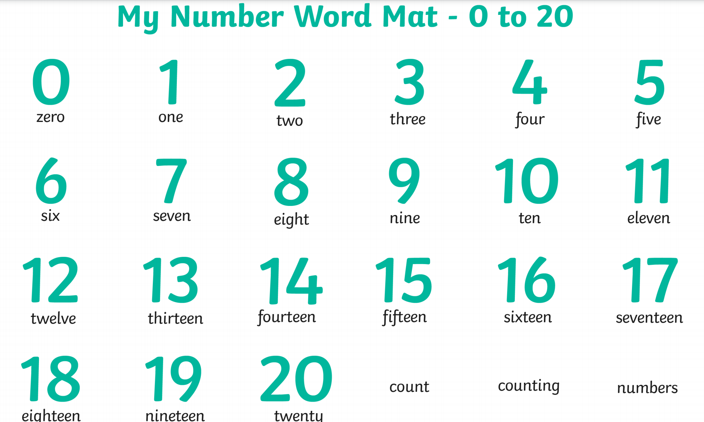
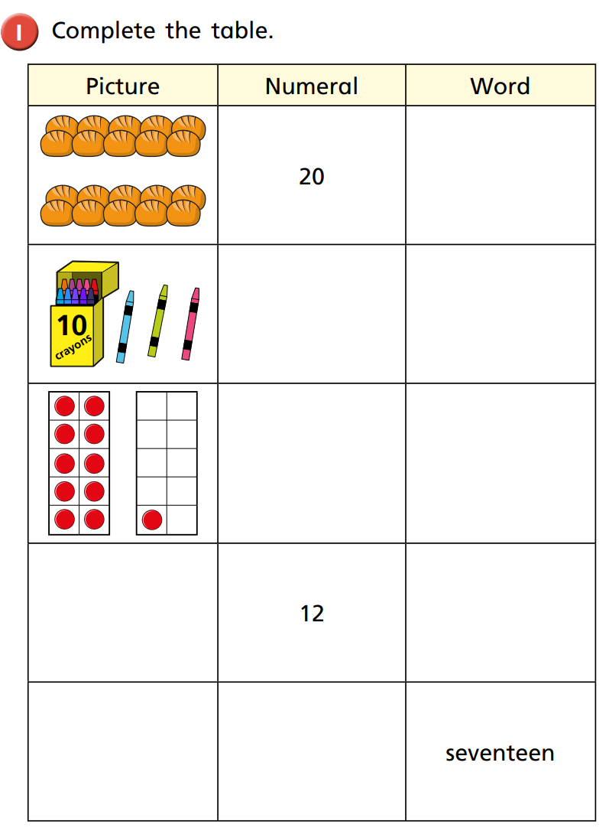
Year 2: Today we are looking at symmetry. Below there are some shapes that are only half completed. The first one has been done for you to show you how to complete each shape.
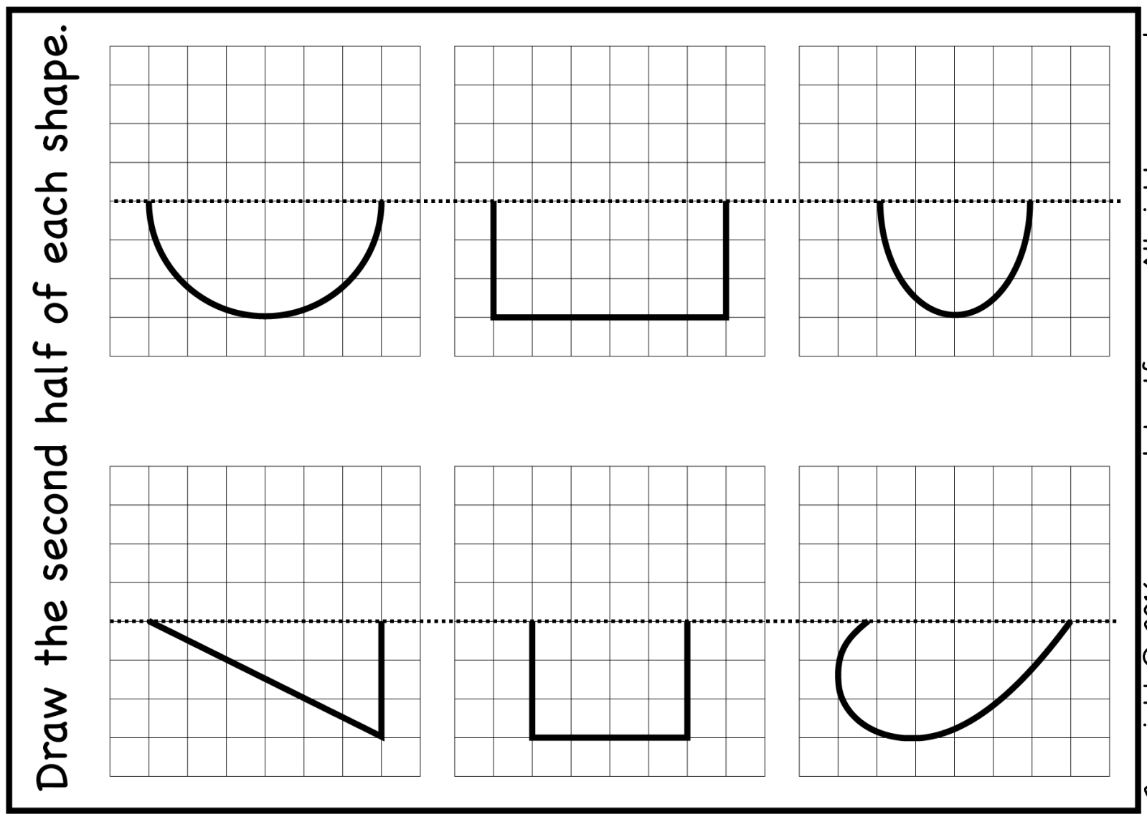
Now join your shape together using a straight line. .
There are 3, so count 3 on the other side.
How many squares are there from the line to the end of the triangle?

