Home Learning (Tuesday)
Year 1 and 2 Maths:
Year 1: Watch this video to help you.
https://www.youtube.com/watch?v=hGD-omqAOPI
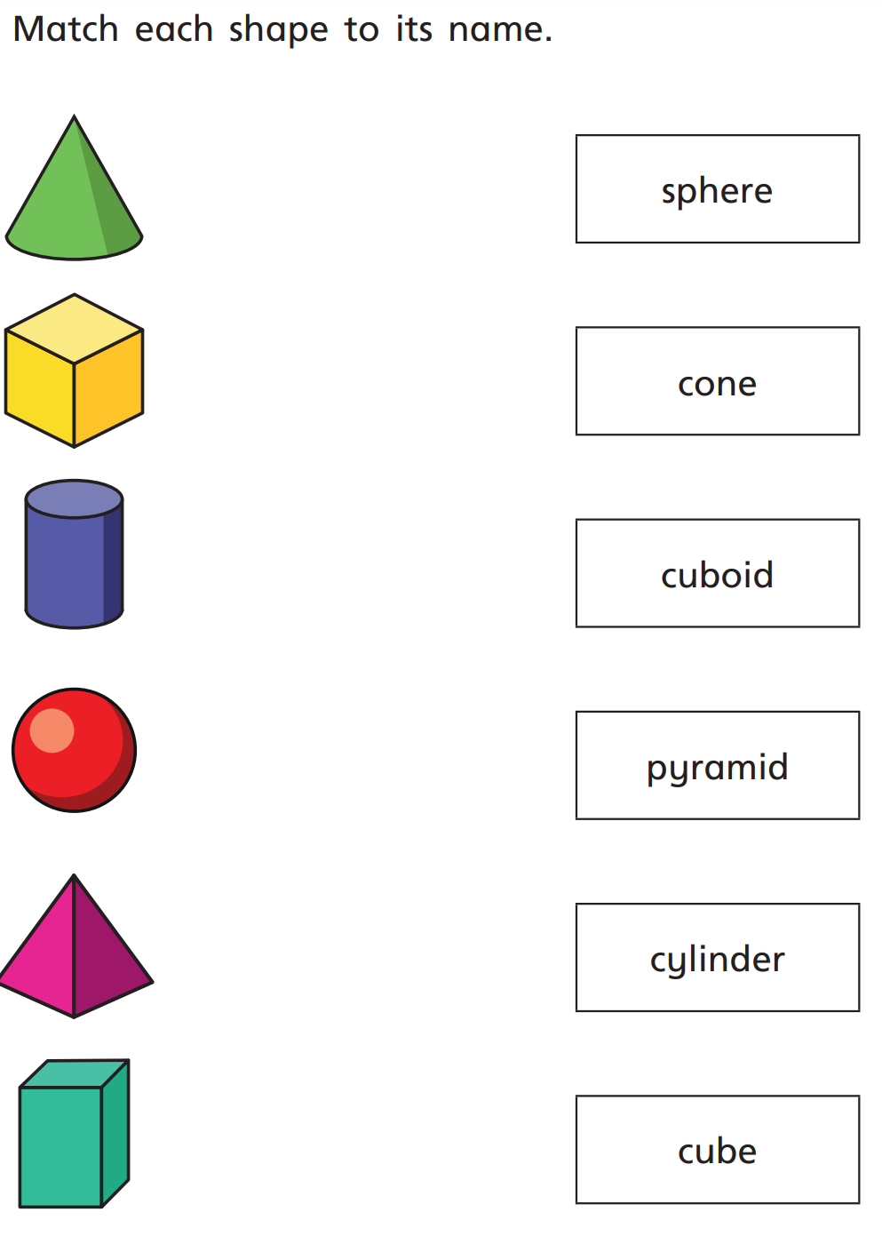

Year 2: Watch this video to help. Watch out, there might be one missing!
https://www.youtube.com/watch?v=hGD-omqAOPI
