**Home Learning**

Please write your sentences on paper if you are unable to print.

**Year 1 and 2 English**

Year 1 and 2: Today, we are going to compare two different dragons. One is the dragon from ‘The Paper Bag Princess’ and the other is from ‘Zog.’ Use the pictures to help you write some comparative sentences. One has been done for you and one has some words missing. Have a go at 2 more on your own.

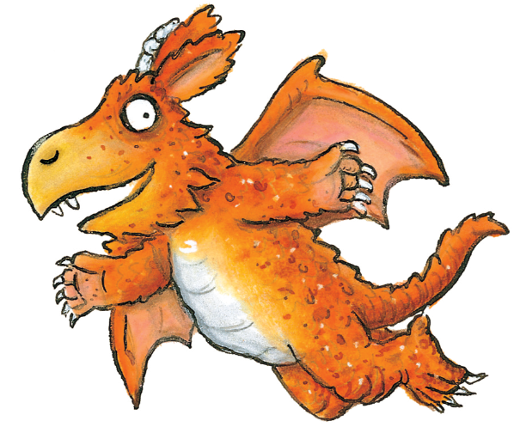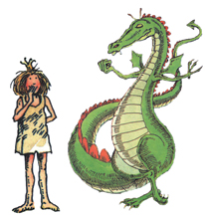

1. One of the dragons is green, and the other one is orange.

2. One has red sp__________ on his tail and the other has sh_________ nails.

3.___________________________________________________________________________________________________________________________________________________________________________________________________________

4.___________________________________________________________________________________________________________________________________________________________________________________________________________