Home Learning
Year 1 and 2 Maths:
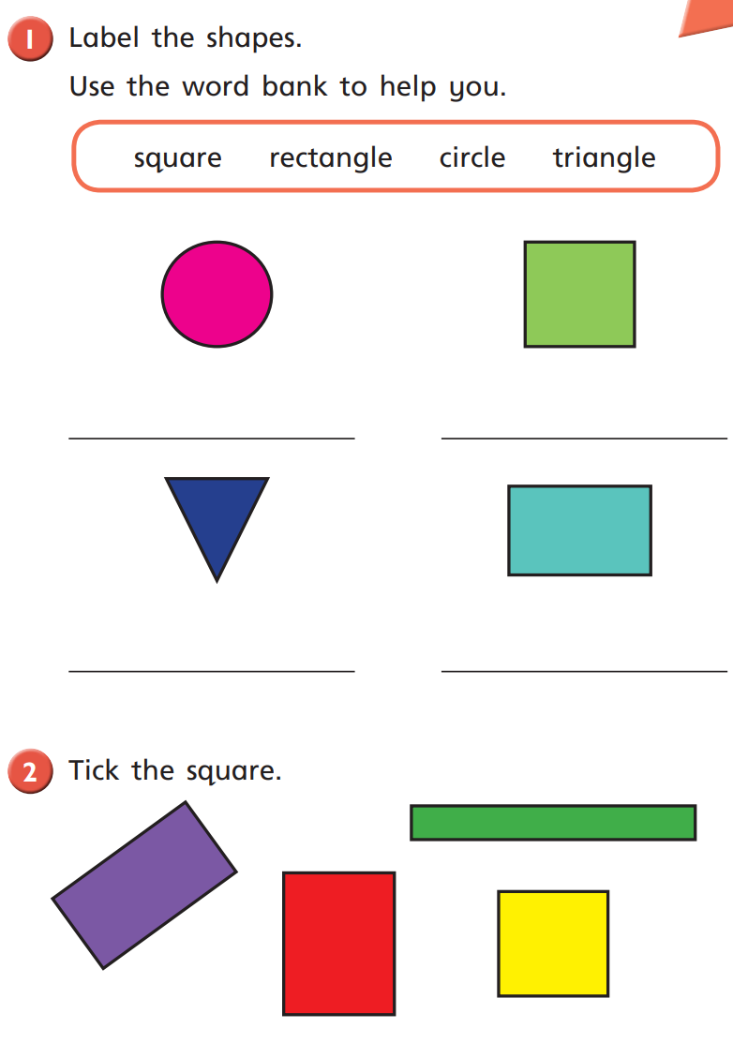
Year 1 – Today, we are going to look at recognising and naming 2D shapes. Have a go at writing the name of each shape next to the correct shape. If you cannot print, please write the name on a piece of paper next to the corresponding question.

b)
a)

d)
c)

Challenge: Tick the square.

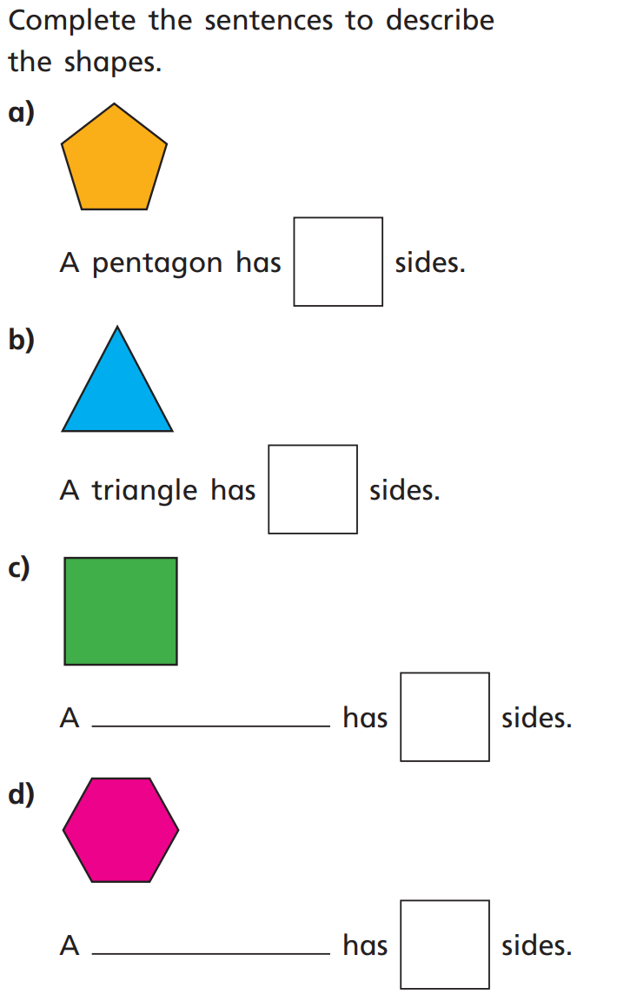
Year 2: Today, we will be learning about the number of sides on different 2D shapes. Have a look below and see if you can answer the questions. If you are unable to print, please write the answers on paper.

