Home Learning
Year 1 and 2 Maths
Below there are some word mats for both 2D and 3D shapes. You are going to go on a shape hunt around your home. Please look at the PowerPoint attached to give you some ideas of what shapes you may find at home.
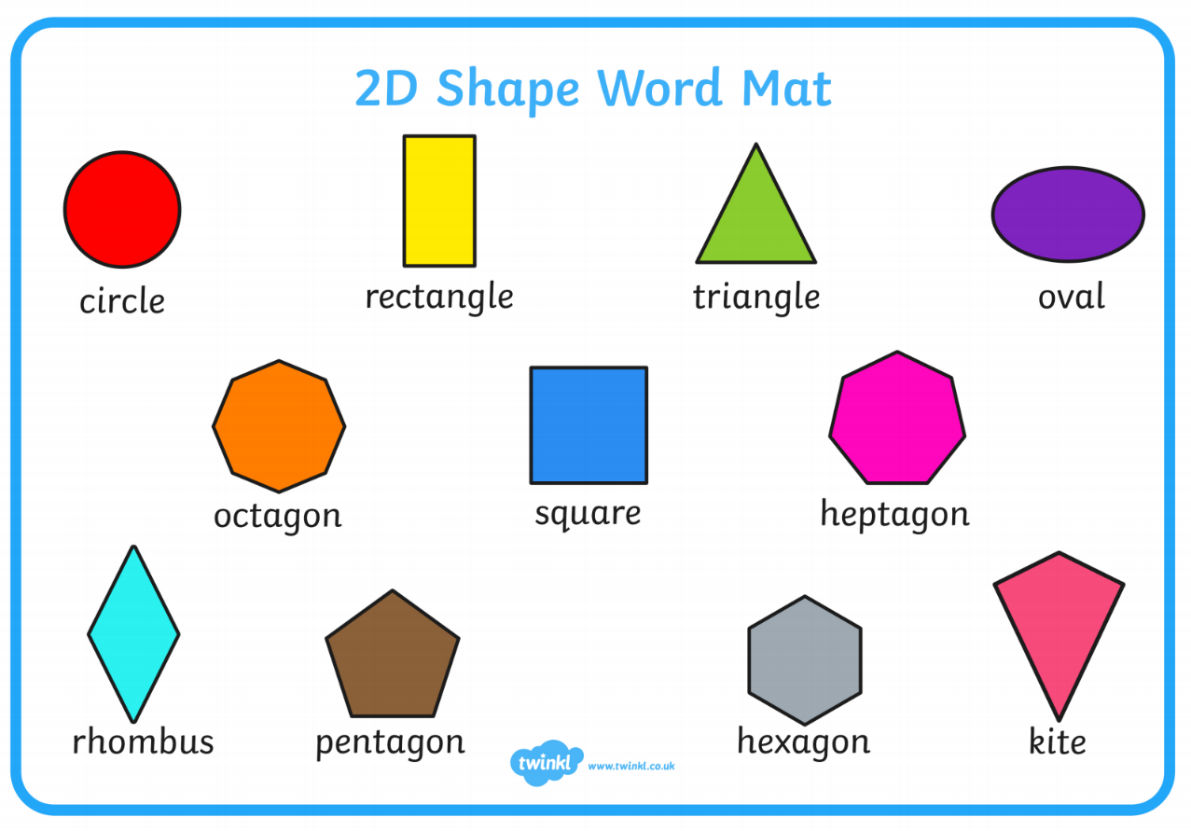
Use the sheet below to write down the shapes you find.
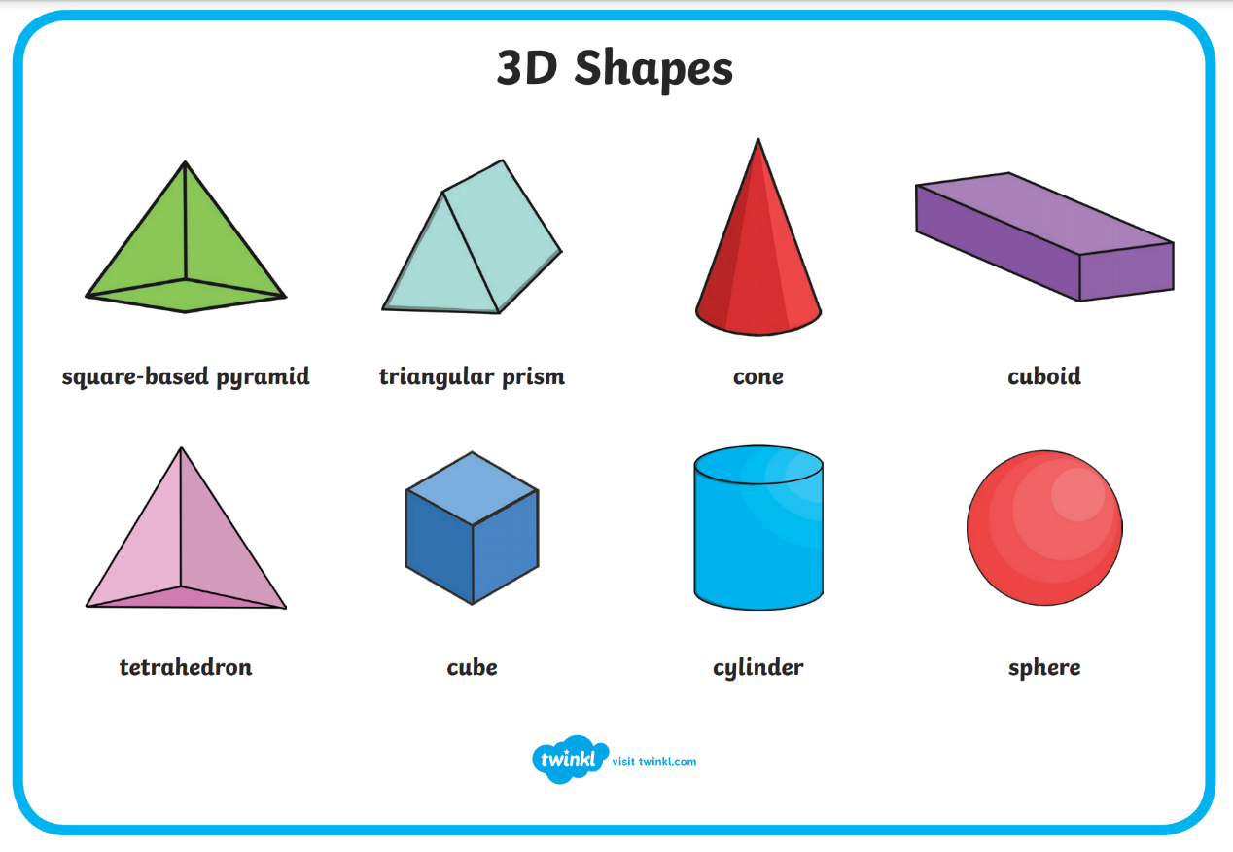

Shape | Real Life Object

