Work from home Term 2 Week 2

**Maths**

**Choose the level you are happiest with, check the answers when you’ve answered a few questions and if they’re correct and you feel confident then try a few questions from the next level. You do not have to answer all the questions.**

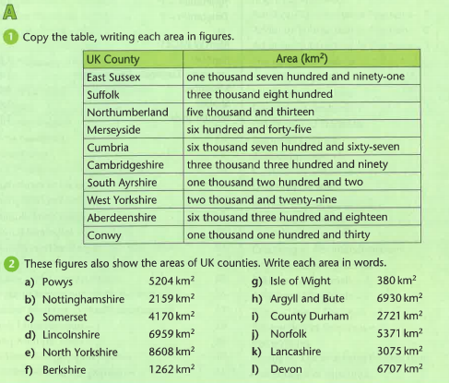

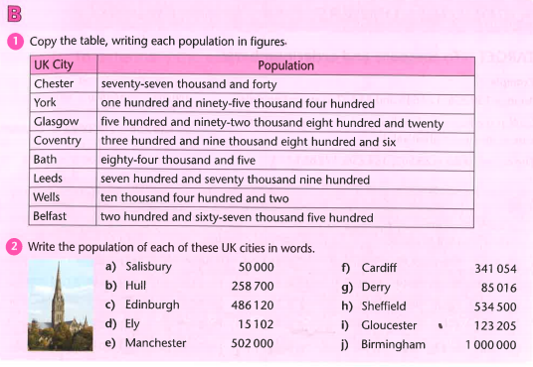

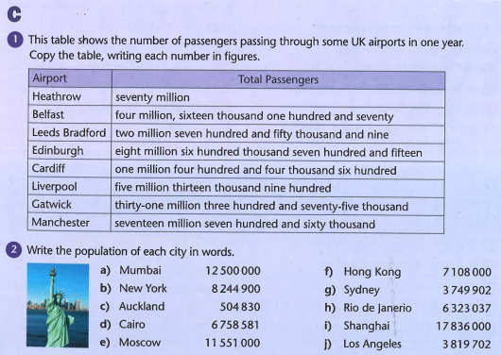

**Challenge**

