Writing
Here is a picture followed by a story starter. Your task today will be to use this starter (if you wish) and extend it to write your own story. Alternatively, you can make up your own beginning. As you do this, could you imagine the camera has zoomed out. Can you describe what is around the owl so that we can understand what he might be doing? Is he IN danger or is he THE danger?
Be as creative as you wish and don’t forget to include:
- Lots of exciting and descriptive phrases
- Parenthesis that adds extra information
- Punctuation to build suspense
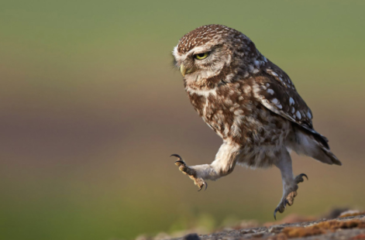

Story starter!
His coal-black pupils, an island set in a sea of molten gold, stared straight ahead of him. As he broke out into a run, his needle-like talons made a sharp, scraping sound against the lichen-covered rocks beneath him.
The wind gusting behind him would be beneficial as he took his leap of faith off the cliff top. It was always a risky business, but when an opportune moment like this came around, he had to make it count…

