Writing
Owliver Twist!!!
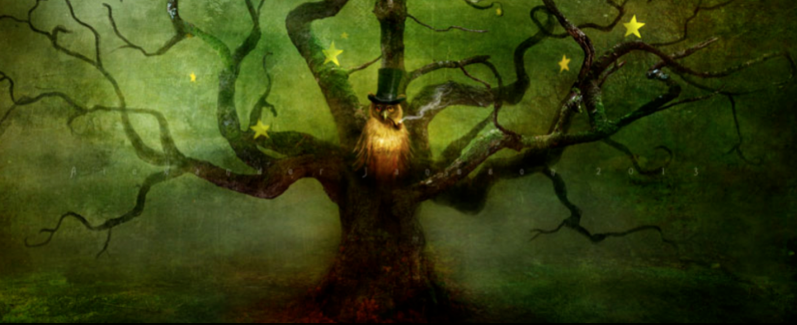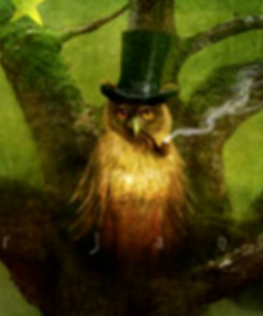
Owliver Twist is not an ordinary owl. Is he a sorcerer, a wizard or a legend? He lived in a tree and it was no ordinary tree. The tree had great magical powers, its roots and tendrils burying and twisting themselves into everything that it came into contact with. Magic flowed from the tree like waves washing over a rocky shore: never ceasing, relentless and consuming.
The tree was the source of all life, and if the tree was the source, Owliver was the creator…

Writing task
Metaphors and Similes are fantastic ways of vividly describing things to the reader. If you want to know more about metaphors and similes visit:
https://www.bbc.co.uk/bitesize/topics/zfkk7ty/articles/z9tkxfr
Can you use some in your writing today to describe the tree and Owliver?
Some examples are:
branches like waves washing over a rocky shore
eyes like lightning piercing through your heart
gaze as compulsively mesmerising as that of a hypnotiser

