WRITING
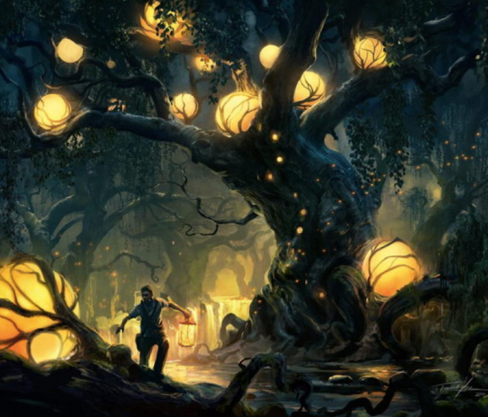
The Party
Story starter!
Placing the final lantern against the twisted, ancient oak, he turned and appreciated his work. The night, that was relished and cherished by all folk who lived in and around the mystical wood of Myr, was here again. Surely this year would be a success. Surely the elves, fairies, dwarves and nightlillies would all turn up on time and enjoy a night of fun and festivities.
He could do no more now except sound the Horn of Anelina to signal the beginning of the party. Reaching down he suddenly froze! Reaching down he realised the space where the horn should be was empty. Then he spotted the note…
Writing task

Writing task
- Sentence challenge!
What are relative clauses? Read and find out here.
https://www.bbc.co.uk/bitesize/topics/zwwp8mn/articles/zsrt4qt
Now read the text and find the main characters in this story? (eg. elves) Can you use relative clauses to add detail about the main characters? Write some good quality sentences using relative clauses.
e.g. Finally the slight and subtle dwarves, who were always last to arrive, appeared just over the horizon.
- Sick sentences!
These sentences are ‘sick’ and need help to get better. Can you help? How can you make them better? Try and add detail, start with a fronted adverbial, use a conjunction to extend them and finally use a variety of punctuation marks (eg semicolon, colon, hyphen, brackets or commas) when adding more clauses.
- The nightlillies loved the bright lights.
- The horn of Anelina is big.
- The man carried lanterns.
- The woods of Myr were large.
- The tree was old.
- Perfect party
If you were to have a party to celebrate something special in your life, what would you use to make it special? Write and draw what you think!

