WRITING
Option 1
Here is a poem using metaphors about James Bond
He is a bar of dark chocolate,
A smooth black cat’s coat,
An exotic fruit cocktail,
A silver Porsche disappearing into the distance.
He is a plate of caviar,
A blade on a knife,
A frothy cappuccino,
A piece of black silk.
He is a midnight alarm,
A tiger disguised as a pussycat,
A jet plane,
A perfect day.
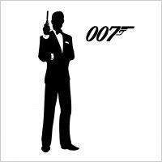

Task
Your task is to write a poem in the same style about either a fictional character or a celebrity. It could be about a character from a book or film. It could be a celebrity from sport, the music industry, the film industry or even the Royal family.

Think about these questions and write some interesting metaphors: What do they look like? What do they do? What are they famous for? What is their character like?

Option 2

Time Travel
One evening you go to your computer and accidentally press one of the keys you have never pressed before. Suddenly you are transported into a different time! Your task is to write about where you travel to, what the place is like, who you meet and how you manage to get home again.
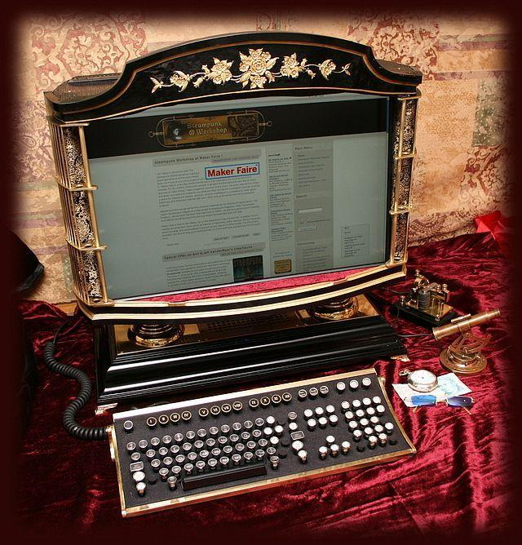

Planning Questions
Where did you travel to and what form did your transport/journey take? (Remember: You can travel back or forwards in time.) What is the place you visit like? Who do you meet? What are they like? How do you manage to get back home?

