Writing – Tuesday
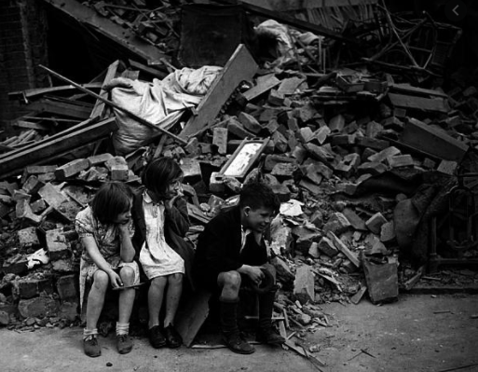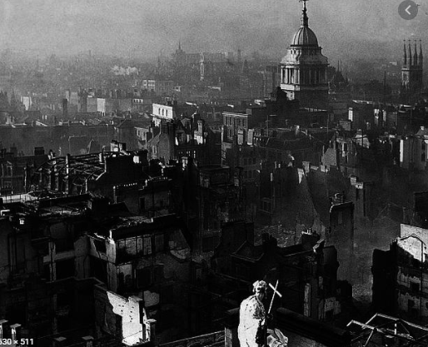
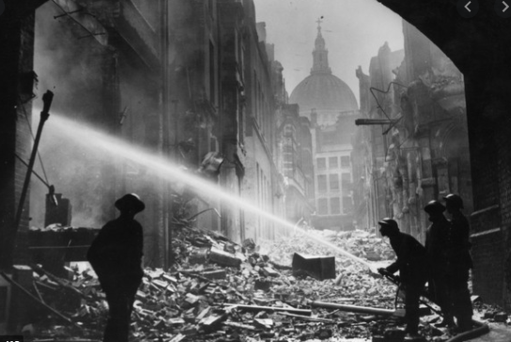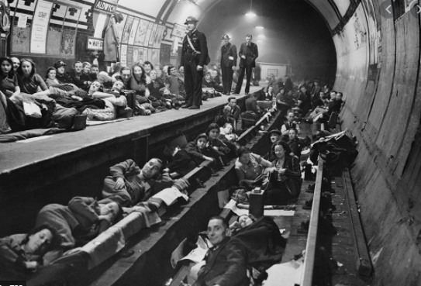
Look at these images of ‘The Blitz’. If you need more information about the event to deepen your understanding, visit https://www.history.com/this-day-in-history/the-blitz-begins
Your task today is to write a description of these images (at least 2 paragraphs). Use your senses to write your description – what do you see, hear, smell and touch.
Your success criteria for this task is as follows:
- Use lots of adjectives
- Include conjunctions to extend your sentences
- Use a variety of sentence openers
- Use higher level vocabulary

