Rabbits Class- Home Learning 15.12.20
Today we are reading ‘Stick Man’ by Julia Donaldson.
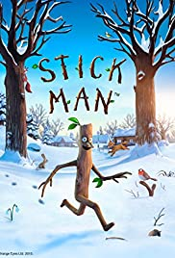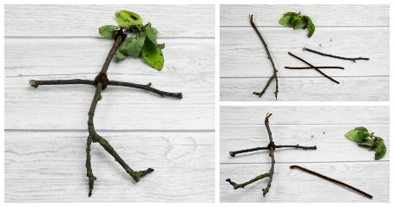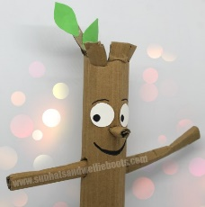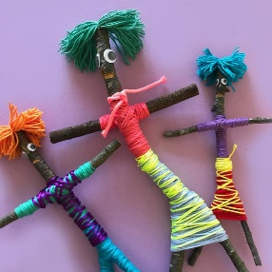
Can you make your own stick man?
In RWI we have been learning…
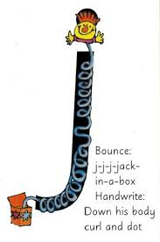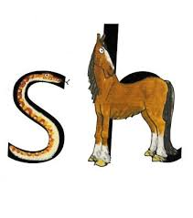
We call these ‘special friends’ because together they make a new sound.

Maths:
Join in with the shape song….. can you draw different triangles, different sizes and some upside down?
https://www.youtube.com/watch?v=Umu58RxNL7I

