7.12 Grammar – Nouns
Match the correct noun to the correct phrase

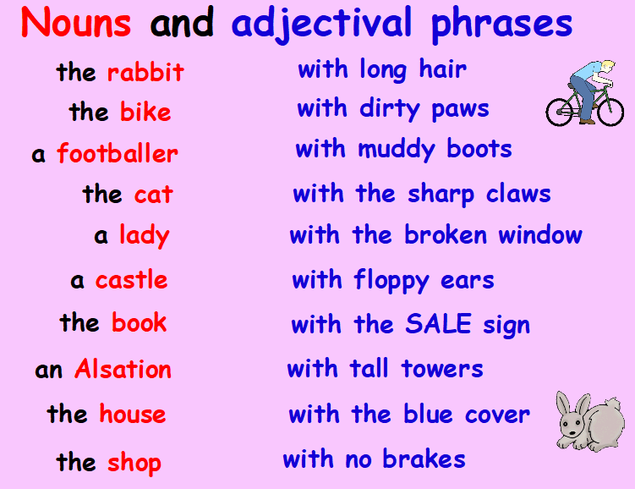

Use each phrase to make up your own interesting sentence. Remember to be as adventurous with your vocabulary and punctuation as you can.

