Rabbits Class- Home Learning
8.12.20
This is the story we are reading this week.
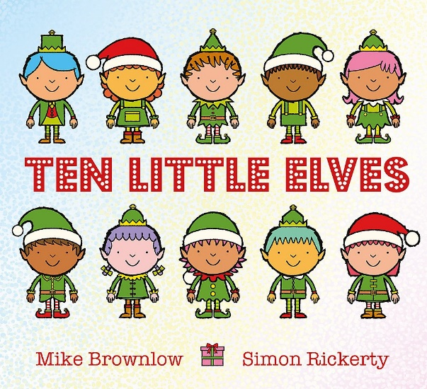
You can find a version being read on youtube.
https://www.youtube.com/watch?v=Jw_p17RPavs

Can you draw, paint or make your own ten little elves?

Practise writing numbers under each one.
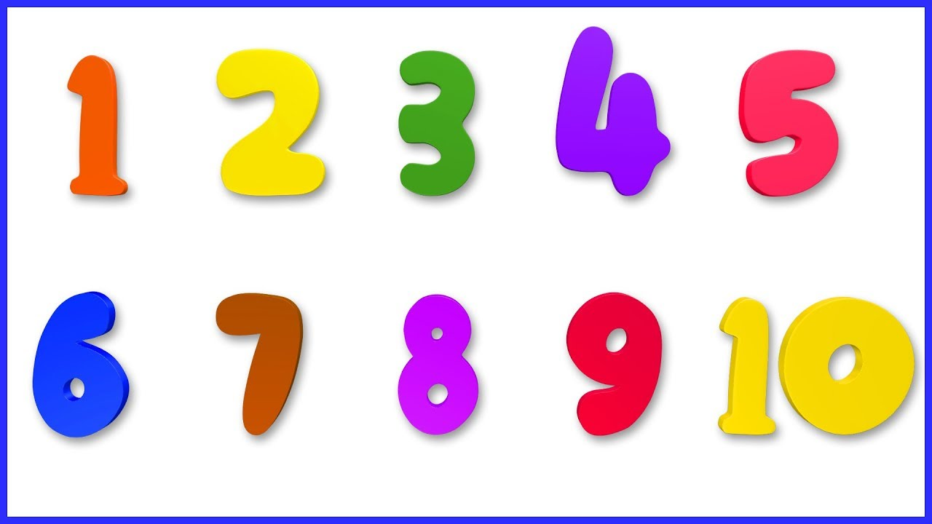
Today we are learning the letter….
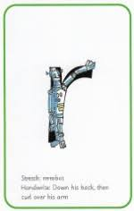 How many things can you think of which start with the sound ‘r’?
Down the robot and over his arm.
Practise writing the letter and saying the sound.

Can you ‘Fred Talk’ and have a go at writing these words?
(red)
(rip)
(run)

