Rabbits Class- Home Learning
9.12.20

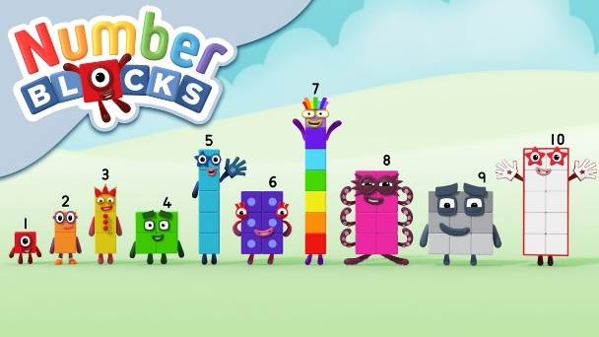
https://www.bbc.co.uk/iplayer/episode/b08phr1g/numberblocks-series-2-ten
Watch the episode and complete the attached sheet.

Have you got any baubles on your Christmas tree?
Can you draw or paint a picture of your tree and add some decorations? You could finger paint it like the one below.
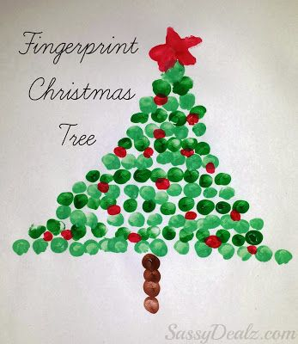
RWI: Can you complete one of the sheets attached using ‘’Fred Talk’ and finding the letters?

